**Brain Damage (Pink Floyd)**

**D G7 D G7**

The lunatic is on the grass, the lunatic is on the grass

**D E7**

Remembering games and daisy chains and laughs

**A7 D**

God to keep the loonies on the path

**D G7 D G7**

The lunatic is in the hall, the lunatics are in my hall

**D E7**

The paper holds their folded faces to the floor

**A7 D D7**

And every day the paperboy brings more

**G A**

And if the dam breaks open many years too soon

**C G**

And if there is no room upon the hill

**A7**

And if your head explodes with dark forbodings too

**C G F#m Em A**

I’ll see you on the dark side of the moon

**D G7 D G7**

The lunatic is in my head, the lunatic is in my head

**D E7**

You raise the blade, you make the change

**A7 D**

You re-arrange me till I’m same

**D E7**

You lock the door and throw away the key

**A7 D D7**

There’s someone in my head but it’s not me

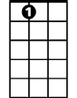

A7

E7

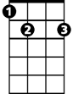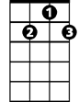

G7

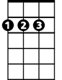

D

**BARITONE**

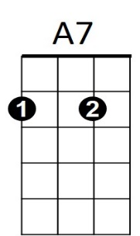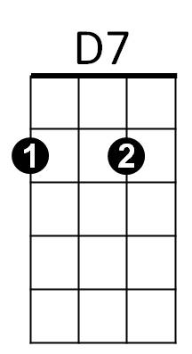

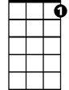

G7

C



D

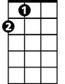

A



G



C

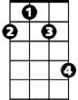

F#m



D7



G



Bb

Em

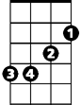

**G A**

And if the cloud bursts thunder in your ear

**C G**

You shout and no one seems to hear

**A7**

And if the band you’re in starts playing different tunes

**C G F#m Em A**

I’ll see you on the dark side of the moon

**(Instrumental)**

**D D7**

All that you touch, and all that you see

**Bb A**

All that you taste – all you feel

**D D7**

And all that you love and all that you hate

**Bb A**

All that you mistrust – all you save

**D D7**

And all that you give and all that you deal

**Bb A**

And all that you buy, beg borrow or steal

**D D7**

And all you create and all you destroy

**Bb A**

And all that you do and all that you say

**D D7**

And all that you eat, and everyone you meet

**Bb A**

And all that you slight and everyone you fight

**D D7**

And all that is now and all that is gone

**Bb A**

And all that’s to come and everting under

**D D7 Bb D**

the sun is in tune but the sun is eclipsed by the mo-on



A

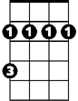

F#m

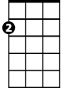

Em

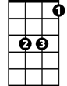

Bb



E7