**Breakfast in America (Richard Davies / Charles Hodgson / Roger Pomfret)**

**Dm C**

Take a look at my girlfriend

**Bb**

She's the only one I got

**Dm C**

Not much of a girlfriend

**Bb**

I never seem to get a lot

**A A7**

Take a jumbo across the water

**Dm**

Like to see America

**A A7**

See the girls in California

**Gm C**

I'm hoping it's going to come true

**Gm C**

But there's not a lot I can do

**Dm C**

Could we have kippers for breakfast

**Bb**

Mummy dear, Mummy dear

**Dm C**

They got to have 'em in Texas

**Bb**

'Cause everyone's a millionaire

**A A7**

I'm a winner, I'm a sinner

**Dm**

Do you want my autograph

**A A7**

I'm a loser, what a joker

**Gm C**

I'm playing my jokes upon you

**Gm C**

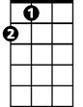

A

While there's nothing better to do, hey

**A A7 Dm**

Ba ba da dum, ba ba, da-d' do da do da do

**A A7 Dm**

Ba ba da dum, ba ba, da-d' do da do da do

**Bb Gm C**

La la la, la la la, la la la la

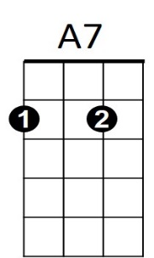

**BARITONE**

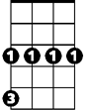

Gm

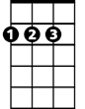

A

C

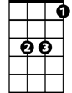

Bb

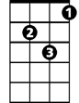

Dm

**Dm C**

Don't you look at my girlfriend, girlfriend

**Bb**

'Cause she's the only one I got

**Dm C**

Not much of a girlfriend, girlfriend

**Bb**

I never seem to get a lot - What's she got? Not a lot

**A A7**

Take a jumbo across the water

**Dm**

Like to see America

**A A7**

See the girls in California

**Gm C**

I'm hoping it's going to come true

**Gm C**

But there's not a lot I can do, hey

**A A7 Dm**

Ba ba da dum, ba ba, da-d' do da do da do

**A A7 Dm**

Ba ba da dum, ba ba, da-d' do da do da do

**A Dm**

Hey u-um, hey u-um, hey u-um, hey u-um

**A Dm**

Hey u-um, hey u-um, hey u-um, hey u-um

**Bb Gm C Dm**

La la la, la la la, la la la la

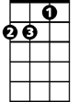

Dm



Bb



C

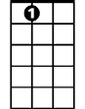

A7



Gm