Breakfast in America (Richard Davies / Charles Hodgson / Roger Pomfret)

Dm C
Take a look at my girlfriend
Bb
She's the only one I got
Dm C
Not much of a girlfriend
Bb
I never seem to get a lot

A A7
Take a jumbo across the water
Dm
Like to see America
A A7
See the girls in California
Gm C
I'm hoping it's going to come true
Gm C
But there's not a lot I can do

Dm C
Could we have kippers for breakfast
Bb
Mummy dear, Mummy dear
Dm C
They got to have 'em in Texas
Bb
'Cause everyone's a millionaire

A A7
I'm a winner, I'm a sinner
Dm
Do you want my autograph
A A7
I'm a loser, what a joker
Gm C
I'm playing my jokes upon you
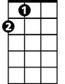
Gm C
A
While there's nothing better to do, hey

A A7 Dm
Ba ba da dum, ba ba, da-d' do da do da do
A A7 Dm
Ba ba da dum, ba ba, da-d' do da do da do
Bb Gm C
La la la, la la la, la la la la
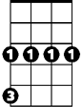
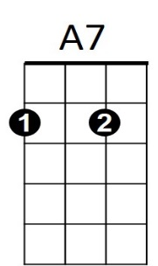
BARITONE
Gm
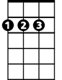

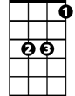
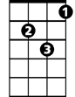
A
C
Bb
Dm

Dm C
Don't you look at my girlfriend, girlfriend
Bb
'Cause she's the only one I got
Dm C
Not much of a girlfriend, girlfriend
Bb
I never seem to get a lot - What's she got? Not a lot

A A7
Take a jumbo across the water
Dm
Like to see America
A A7
See the girls in California
Gm C
I'm hoping it's going to come true
Gm C
But there's not a lot I can do, hey

A A7 Dm
Ba ba da dum, ba ba, da-d' do da do da do
A A7 Dm
Ba ba da dum, ba ba, da-d' do da do da do
A Dm
Hey u-um, hey u-um, hey u-um, hey u-um
A Dm
Hey u-um, hey u-um, hey u-um, hey u-um
Bb Gm C Dm
La la la, la la la, la la la la
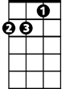


Dm
Bb
C

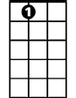
A7
Gm

