Brown Eyed Girl (Van Morrison, 1967) (C)
Brown Eyed Girl by Van Morrison (1967) (G)
4/4 Time – Tempo = 151

Intro C F C G7 (2x)  C F C G7  Hey, where did we go? Days when the rains came  C F C G7  Down in the hollow playin' a new game.  C F C G7  Laughing and a - running, hey hey, Skipping and a - jumping  C F C G7 F  In the misty morning fog with Our ~ hearts a - thumping and you  G7 C Am F G7 C G7  My brown-eyed girl you-u, my brown-eyed girl  C F C G7  Whatever happened to Tuesday and so slow  C F C G7  Going down the old mine with a transistor radio  C F C G7  Standing in the sunlight laughing, hiding behind a rainbow's wall.  C F C G7 F  Slipping and a – sliding all along the waterfall with you  G7 C Am F G7 C G7  My brown-eyed girl you-u, my brown-eyed girl  G7 C  Do you remember when ~ we used to sing:  F C G7  Sha la la la la la la la la la la te da  C F C G7 C G7  Sha la la la la la la la la la la te da - la te da  C F C G7  So hard to find my way, now that I'm all on my own  C F C G7  I saw you just the other day, my, how you have grown  C F C G7  Cast my memory back there, Lord, sometimes I'm overcome thinking 'bout  C F C G7 F  Making love in the green grass behind the stadium with you  G7 C Am F G7 C G7  My brown-eyed girl you-u, my brown-eyed girl  G7 C  Do you remember when ~ we used to sing:  F C G7  Sha la la la la la la la la la la te da (3x)  C F C G7 C G7 C  Sha la la la la la la la la la la te da, la te da. | 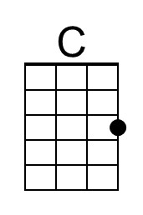
 | 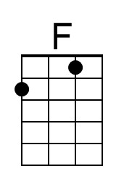
 | 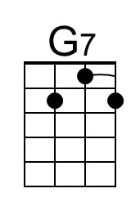
 | 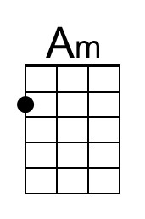
 | 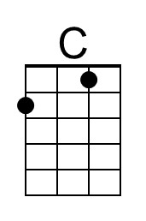
 | 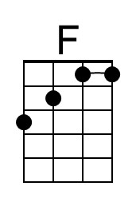
 | 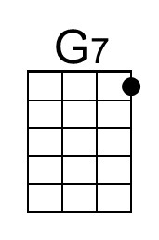
 | 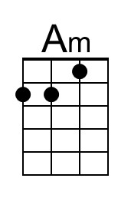

Brown Eyed Girl (Van Morrison, 1967) (G)
Brown Eyed Girl by Van Morrison (1967) (G)
4/4 Time – Tempo = 151

Intro G C G D7 (2x)  G C G D7  Hey, where did we go? Days when the rains came  G C G D7  Down in the hollow playin' a new game.  G C G D7  Laughing and a - running, hey hey, Skipping and a - jumping  G C G D7 C  In the misty morning fog with Our ~ hearts a - thumping and you  D7 G Em C D7 G D7  My brown-eyed girl you-u, my brown-eyed girl  G C G D7  Whatever happened to Tuesday and so slow  G C G D7  Going down the old mine with a transistor radio  G C G D7  Standing in the sunlight laughing, hiding behind a rainbow's wall.  G C G D7 C  Slipping and a - sliding all along the waterfall with you  D7 G Em C D7 G D7  My brown-eyed girl you-u, my brown-eyed girl  D7 G  Do you remember when ~ we used to sing:  C G D7  Sha la la la la la la la la la la te da  G C G D7 G D7  Sha la la la la la la la la la la te da - la te da  G C G D7  So hard to find my way, now that I'm all on my own  G C G D7  I saw you just the other day, my, how you have grown  G C G D7  Cast my memory back there, Lord, sometimes I'm overcome thinking 'bout  G C G D7 C  Making love in the green grass behind the stadium with you  D7 G Em C D7 G D7  My brown-eyed girl you-u, my brown-eyed girl  D7 G  Do you remember when ~ we used to sing:  C G D7  Sha la la la la la la la la la la te da (3x)  G C G D7 G D7 G  Sha la la la la la la la la la la te da, la te da. | 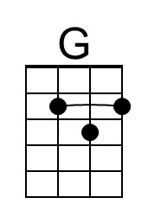
 | 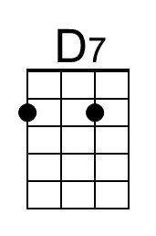
 | 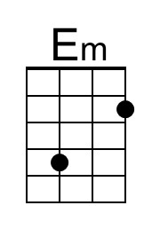
 | 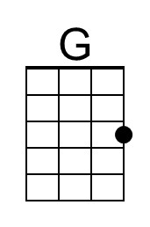
 | 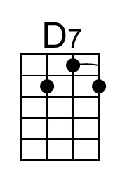
 | 