**Brown-Eyed Girl (Van Morrison)**

**Intro (play twice): C F C G7**

**C F**

Hey, where did we go?

**C G7**

Days when the rains came

**C F C G7**

Down in the hollow - playin' a new game

**C F**

Laughing and a - running, hey hey,

**C G7**

Skipping and a - jumping

**C F**

In the misty morning fog with -

**C G7 F**

Our ~ hearts a - thumping and you

**G7 C Am**

My brown-eyed girl

**F G7 C G7**

You-u, my brown-eyed girl

**C F C G7**

Whatever happened to Tuesday and so slow

**C F C G7**

Going down the old mine with a - transistor radio

**C F**

Standing in the sunlight laughing

**C G7**

Hiding behind a rainbow's wall

**C F**

Slipping and a - sliding

**C G7 F**

All along the waterfall with you

**G7 C Am**

My brown-eyed girl

**F G7 C G7**

You, my brown-eyed girl

**G7 C**

Do you remember when we used to sing:

**F C G7**

Sha la la la la la la la la la la te da

**C F C G7 C G7**



F

**BARITONE**

C

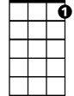

G7

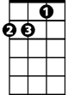

Am

Sha la la la la la la la la la la te da, la te da

**C F**

So hard to find my way,

**C G7**

Now that I'm all on my own

**C F**

I saw you just the other day,

**C G7**

My, how you have grown

**C F**

Cast my memory back there, Lord

**C G7**

Sometimes I'm overcome thinking 'bout

**C F**

Making love in the green grass

**C G7 F**

Behind the stadium with you -

**G7 C Am**

My brown-eyed girl

**F G7 C G7**

You, my brown-eyed girl

**G7 C**

Do you remember when we used to sing:

**F C G7**

Sha la la la la la la la la la la te da

**C F C G7 C**

Sha la la la la la la la la la la te da, la te da

**F C G7**

Sha la la la la la la la la la la te da

**C F C G7 C**

Sha la la la la la la la la la la te da, la te da

**C F C G7 C**



C

F

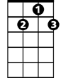

G7

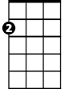

Am

**Brown-Eyed Girl (Van Morrison) Key G**

**Intro (play twice): G C G D7**

**G C**

Hey, where did we go?

**G D7**

Days when the rains came

**G C G D7**

Down in the hollow playin' a new game

**G C**

Laughing and a - running, hey hey,

**G D7**

Skipping and a - jumping

**G C**

In the misty morning fog with

**G D7 C**

Our ~ hearts a - thumping and you

**D7 G Em**

My brown-eyed girl

**C D7 G D7**

You-u, my brown-eyed girl

**G C G D7**

Whatever happened to Tuesday and so slow

**G C G D7**

Going down the old mine with a transistor radio

**G C**

Standing in the sunlight laughing

**G D7**

Hiding behind a rainbow's wall

**G C**

Slipping and a - sliding

**G D7 C**

All along the waterfall with you

**D7 G Em**

My brown-eyed girl

**C D7 G D7**

You, my brown-eyed girl

**D7 G**

Do you remember when we used to sing:

**C G D7**

Sha la la la la la la la la la la te da

**G C G D7 G D7**

**BARITONE**

C



Em



G



D7

Sha la la la la la la la la la la te da, La te da

**G C**

So hard to find my way,

**G D7**

Now that I'm all on my own

**G C**

I saw you just the other day,

**G D7**

My, how you have grown

**G C**

Cast my memory back there, lord

**G D7**

Sometimes I'm overcome thinking 'bout

**G C**

Making love in the green grass

**G D7 C**

Behind the stadium with you

**D7 G Em**

My brown-eyed girl

**C D7 G D7**

You, my brown-eyed girl

**D7 G**

Do you remember when we used to sing:

**C G D7**

Sha la la la la la la la la la la te da

**G C G D7 G**

Sha la la la la la la la la la la te da, La te da

**C G D7**

Sha la la la la la la la la la la te da

**G C G D7 G**

Sha la la la la la la la la la la te da, La te da

**G C G D7 G**

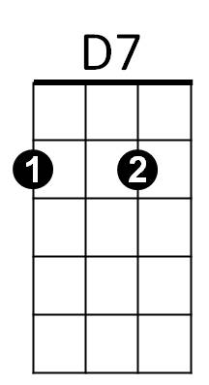

Em

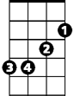

C



G