**Bus Stop (Graham Gouldman)**

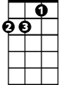

Dm



G

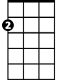

Am

**Intro: Dm G (x2)**

**Dm Am Dm Am**

Bus stop, wet day, she's there, I say

**Dm Am Dm Am**

Please share my umbrella

**Dm Am Dm Am**

Bus stop, bus goes, she stays, love grows

**Dm Am Dm Am**

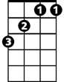

Bb



A7

F

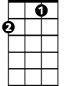

Under my umbrella

**F G Dm**

All that summer we enjoyed it

**Bb A7**

Wind and rain and shine

**Dm Am Dm Am**

E7

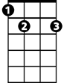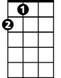

A

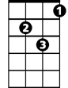

Gm

That umbrella, we employed it

**Dm Am Dm**

By August she was mine

**Chorus:**

**F E7 Am G F**

Every morning I would see her waiting at the stop

**Gm E7 A**

Sometimes she shopped and she would show me what she bought

**F E7 Am G F**

Other people stared as if we were both quite insane

**G E7 A**

Someday my name and hers are going to be the same

**BARITONE**

**Dm Am Dm Am**

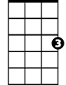

G



F



Am

That's the way the whole thing started

**Dm Am Dm Am**

Silly but it's true

**Dm Am Dm Am**

Thinkin' of a sweet romance

**Dm Am Dm Am**

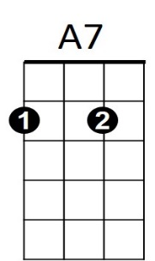Beginning in a queue



Dm

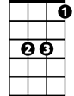

Bb

**F G Dm**

Came the sun the ice was melting

**Bb A7**

No more sheltering now

**Dm Am Dm Am**

Nice to think that that umbrella

**Dm Am Dm**



E7

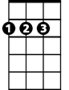

A

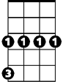

Gm

Led me to a vow

**(Chorus)**

**(Repeat song through chorus)**

**Dm Am Dm Am (fade)**