**Buy for Me the Rain (Greg Copeland / Steve Noonan) Key G**

**Intro: G F G (2x)**



G

F



**F G**

Buy for me the rain, my darling, buy for me the rain;

**F G**

Buy for me the crystal pools that fall upon the plain.

**C D7**

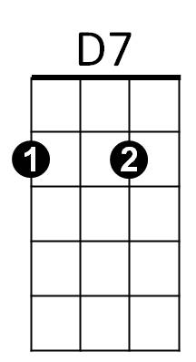And I'll buy for you a rainbow and a million pots of gold.



C

**G F G G F G**

Buy it for me now, babe, before I am too old.

**F G**

Buy for me the sun, my darling, buy for me the sun;

**F G**

Buy for me the light that falls when day has just begun.

**C D7**

And I'll buy for you a shadow to protect you from the day.

**G F G G F G**

Buy it for me now, babe, before I go away.

**F G**

Buy for me the robin, darling, buy for me the wing;

**F G**

Buy for me a sparrow, almost any flying thing.

**C D7**

And I'll buy for you a tree, my love, where a robin's nest may grow.

**G F G G F G**

Buy it for me now, babe, the years all hurry so.

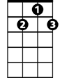

D7

**BARITONE**



G



F

C



**F G**

I cannot buy you happiness, I cannot by you years;

**F G**

I cannot buy you happiness, in place of all the tears.

**C D7**

But I can buy for you a gravestone, to lay behind your head.

**G F G**

Gravestones cheer the living, dear, they're no use to the dead.

**G F G (repeat to fade)**

**Buy for Me the Rain (Greg Copeland / Steve Noonan) Key C**

**Intro: C Bb C (2x)**

**Bb C**

Buy for me the rain, my darling, buy for me the rain;

**Bb C**

Buy for me the crystal pools that fall upon the plain.



C



Bb

**F G7**

And I'll buy for you a rainbow and a million pots of gold.

**C Bb C C Bb C**

Buy it for me now, babe, before I am too old.

**Bb C**

F



G7

Buy for me the sun, my darling, buy for me the sun;

**Bb C**

Buy for me the light that falls when day has just begun.

**F G7**

And I'll buy for you a shadow to protect you from the day.

**C Bb C C Bb C**

Buy it for me now, babe, before I go away.

**Bb C**

Buy for me the robin, darling, buy for me the wing;

**Bb C**

Buy for me a sparrow, almost any flying thing.

**F G7**

And I'll buy for you a tree, my love, where a robin's nest may grow.

**C Bb C C Bb C**

Buy it for me now, babe, the years all hurry so.

**Bb C**

I cannot buy you happiness, I cannot by you years;

**Bb C**

**BARITONE**

C

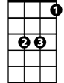

Bb

I cannot buy you happiness, in place of all the tears.

**F G7**

But I can buy for you a gravestone, to lay behind your head.

**C Bb C**

Gravestones cheer the living, dear, they're no use to the dead.



F

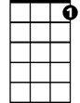

G7

**C Bb C (repeat to fade)**