By The Light Of The Silvery Moon Key (Edward Madden / Gus Edwards) Key G

Chorus:  G C E7 A7  By the light of the silvery moon  D7  I want to spoon  G E D7  To my honey I'll croon love's tune  G C E7 A7  Honey moon, keep a-shinin' in June  G C G  Your silvery beams will bring love's dreams  G E7 A7 D7 G D7  We'll be cuddlin' soon - By the silvery moon  G E7 A7 D7  Place - park, scene - dark  G D7  Silvery moon is shining through the trees  Am D7 Am  Cast - two, me - you  D7 G  Summer kisses floating on the breeze  G E7 A7 D7  Act one, be - gun  G D7  Dialog - where would ya like to spoon?  C Am G  My cue, with you  A A7 D D7  Underneath the silvery moon  (Chorus)  Baritone |  |  |  | G E7 A7 D7  Act - two, Scene - new  G D7  Roses blooming all around the place  Am D7 Am  Cast - three, You - me  D7 G  Preacher with a solemn-looking face  G E7 A7 D7  Choir sings, bell rings  G D7  Preacher: You are wed forever more  C Am G  Act two, all though  A A7 D D7  Every night the same encore  G  By the light, (not the dark but the light)  C E7 A7  Of the silvery moon, (not the sun but the moon)  D7 Am D7  I want to spoon, (not croon, but spoon)  G E D7  To my honey I'll croon love's tune  G  Honeymoon, (honey moon, honey moon)  C E7 A7  Keep a-shinin' in June  G C G  Your silvery beams will bring love's dreams  G E7 A7 D7 G  We'll be cuddlin' soon - By the silvery moon |  |  |  | 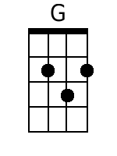
 |  |  |  |  |  |  |  | 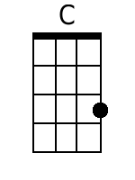
 |  |  |  |  |  |  |  | 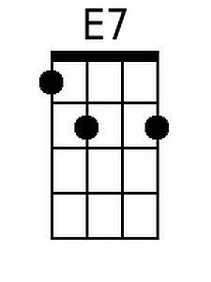
 |  |  |  |  |  |  |  | 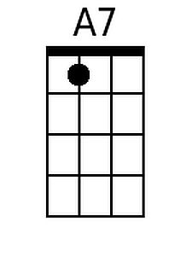
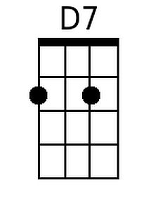
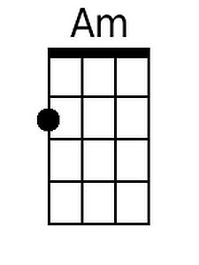
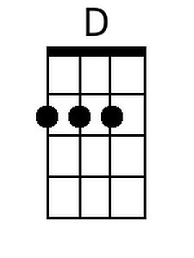
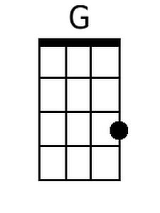 | 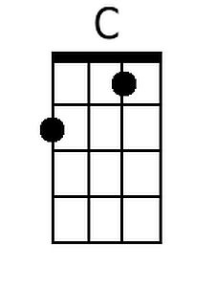 | 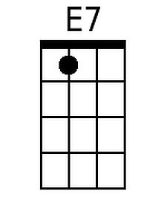 | 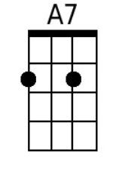 | 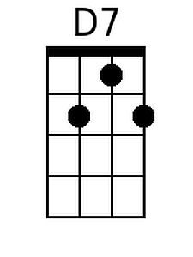 | 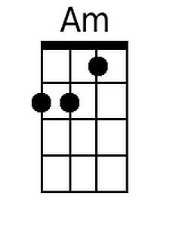 | 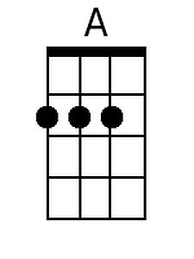 | 