**By the Light of the Silvery Moon (Edward Madden / Gus Edwards)**

**Chorus:**

**C F A7 D7**

By the light of the silvery moon

**G7**

I want to spoon

**C A G7**

To my honey I'll croon love's tune

**C F A7 D7**

Honey moon, keep a-shinin' in June

**C F C**

Your silvery beams will bring love's dreams

**C A7 D7 G7 C G7**

We'll be cuddlin' soon - By the silvery moon

**C A7 D7 G7**

Place - park, scene - dark

**C G7**

Silvery moon is shining through the trees

**Dm G7 Dm**

Cast - two, me - you

**G7 C**

Summer kisses floating on the breeze

**C A7 D7 G7**

Act one, be - gun

**C G7**

Dialog - where would ya like to spoon?

**F Dm C**

My cue, with you

**D D7 G G7**

Underneath the silvery moon

**(CHORUS)**

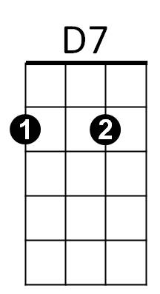

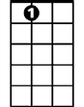

A7

F



C

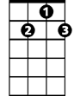

G7

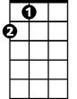

A

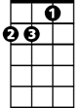

Dm

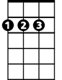

D

**C A7 D7 G7**

Act - two, Scene - new

**C G7**

Roses blooming all around the place

**Dm G7 Dm**

Cast - three, You - me

**G7 C**

Preacher with a solemn-looking face

**C A7 D7 G7**

Choir sings, bell rings

**C G7**

Preacher: You are wed forever more

**F Dm C**

Act two, all though

**D D7 G G7**

Every night the same encore

**C**

By the light, (not the dark but the light)

**F A7 D7**

Of the silvery moon, (not the sun but the moon)

**G7 Dm G7**

I want to spoon, (not croon, but spoon)

**C A G7**

To my honey I'll croon love's tune

**C**

Honeymoon, (honey moon, honey moon)

**F A7 D7**

Keep a-shinin' in June

**C F C**

Your silvery beams will bring love's dreams

**C A7 D7 G7 C**

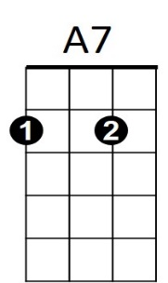We'll be cuddlin' soon - By the silvery moon

C



F

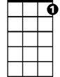

G7



A

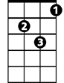

Dm



D



D7

**BARITONE**