C’est La Vie (Chuck Berry, early 1960s) (C)

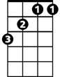  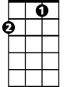  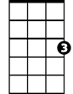  C  It was a teen-aged wedding  And the old folks wished them well  You could see that Pierre  G  Truly loved the mademoiselle  And now the young Monsieur and Madame  Have rung the chapel bell  C'est La Vie, say the old folks  C  It goes to show you never can tell  C  They furnished off the apartment  With a two room tag-end sale  The coolerator was crammed  G  With TV dinners and Ginger Ale  But when Pierre found work  The little money come in, worked out well  C'est La Vie, say the old folks  C  It goes to show you never can tell. |  |  |  |  | C  They had a hi-fi phono  Boy, did they let it blast  700 little records  G  All rock and rhythm and jazz  But when the sun went down  The rapid tempo of the music fell  C'est La Vie say the old folks  C  It goes to show you never can tell  C  They bought a souped up chitney  Was cherry red fifty-three  Drove it down to Orleans  G  To celebrate their anniversary  It was there where Pierre was wedded  To the lovely mademoiselle  C'est La Vie say the old folks  C  It goes to show you never can tell  (Repeat First Verse)  G  C'est La Vie, say the old folks  C  It goes to show you never can tell
GCEA | 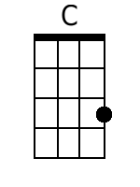 | 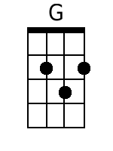 |  |  |  | DGBE | 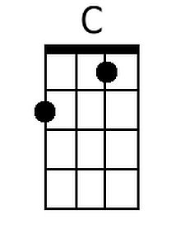 | 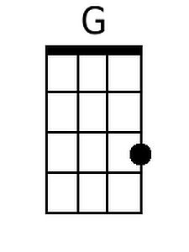

C’est La Vie (Chuck Berry, early 1960s) (F)

F  It was a teen-aged wedding  And the old folks wished them well  You could see that Pierre  C  Truly loved the mademoiselle  And now the young Monsieur and Madame  Have rung the chapel bell  C'est La Vie, say the old folks  F  It goes to show you never can tell  F  They furnished off the apartment  With a two room tag-end sale  The coolerator was crammed  C  With TV dinners and Ginger Ale  But when Pierre found work  The little money come in, worked out well  C'est La Vie, say the old folks  F  It goes to show you never can tell |  |  |  |  | F  They had a hi-fi phono  Boy, did they let it blast  700 little records  C  All rock and rhythm and jazz  But when the sun went down  The rapid tempo of the music fell  C'est La Vie say the old folks  F  It goes to show you never can tell  F  They bought a souped up chitney  Was cherry red fifty-three  Drove it down to Orleans  C  To celebrate their anniversary  It was there where Pierre was wedded  To the lovely mademoiselle  C'est La Vie say the old folks  F  It goes to show you never can tell  (Repeat First Verse)  C  C'est La Vie, say the old folks  F  It goes to show you never can tell
GCEA | 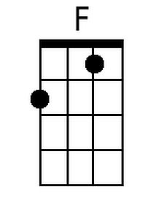 |  |  |  |  | DGBE | 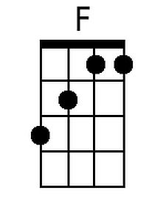

C’est La Vie (Chuck Berry, early 1960s) (NN)

1  It was a teen-aged wedding  And the old folks wished them well  You could see that Pierre  5  Truly loved the mademoiselle  And now the young Monsieur and Madame  Have rung the chapel bell  C'est La Vie, say the old folks  1  It goes to show you never can tell  1  They furnished off the apartment  With a two room tag-end sale  The coolerator was crammed  5  With TV dinners and Ginger Ale  But when Pierre found work  The little money come in, worked out well  C'est La Vie, say the old folks  1  It goes to show you never can tell  1  They had a hi-fi phono  Boy, did they let it blast  700 little records  5  All rock and rhythm and jazz  But when the sun went down  The rapid tempo of the music fell  C'est La Vie say the old folks  1  It goes to show you never can tell | 1  They bought a souped up chitney  Was cherry red fifty-three  Drove it down to Orleans  5  To celebrate their anniversary  It was there where Pierre was wedded  To the lovely mademoiselle  C'est La Vie say the old folks  1  It goes to show you never can tell  (Repeat First Verse)  5  C'est La Vie, say the old folks  1  It goes to show you never can tell
 |  |  | 1 | 5
 |  |  | A | E
 |  |  | C | G
 |  |  | D | A
 |  |  | F | C
 |  |  | G | D

