**The Caissons Go Rolling Along (Edmund L. Gruber 1908)**

**The Field Artillery Song (John Philip Sousa 1917)**

**C**

F

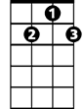

G7



C

Over hill, over dale, as we hit the dusty trail,

**G7 C**

And the caissons go rolling a-long.

**C**

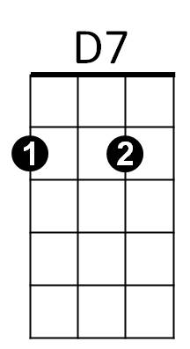In and out, hear them shout,

E7

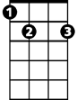

Counter-march and right about,

**G7 C**

And the caissons go rolling a-long.

**C F C**

Then it's hi! hi! hee! In the Field Ar-til-ler-y,

**D7 G7**

Shout out your numbers loud and strong,

**C E7 F C**

For where e'er you go, you will always know,

**G7 C**

That the caissons go rolling along.

(Keep them rolling!)

**G7 C**

Yes, those caissons go rolling along!

**The Army Goes Rolling Along (1956)**

**C F**

March along, sing our song,

**C G7 C**

With the Army of the free.

**C F**

Count the brave, count the true,

**E7 B7 E7**

who have fought to victo -ry.

**Dm Am**

We’re the Army and proud of our name!

**E7 G7**

We’re the Army and proudly proclaim:

**C**

First to fight for the right,

And to build the Nation’s might,

**G7 C**

And the Army Goes Rolling Along.

**C**



C

Proud of all we have done,

Fighting till the battle’s won,

**G7 C**

And the Army Goes Rolling Along.

**Refrain:**

**C F C**

Then it’s hi! hi! hey! The Army’s on its way.

**D7 G7**

Count off the cadence loud and strong;

**C E7 F C**

For where’er we go, You will always know

**G7 C**

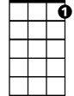

G7

B7

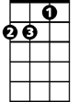

Am

C



F

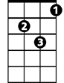

Dm

That the Army Goes Rolling Along.

**BARITONE**

**C**

Valley Forge, Custer’s ranks,

San Juan Hill and Patton;s tanks

**G7 C**



D7

And the Army went Rolling Along.

**C**

Minute Men, from the start,

always fighting from the heart,

**G7 C**

And the Army Goes Rolling Along.

**(Refrain)**

**C**

Men in rags, men who froze,

still that Army met its foes,

**G7 C**

And the Army went Rolling Along.

**C**

Faith in God, then we’re right,

and we’ll fight with all our might,

**G7 C**

And the Army Goes Rolling Along.

**(Refrain)**

(Keep them rolling!)

**G7 C**

That the Army Goes Rolling Along.

E7



G7

F

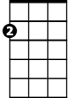

Am



Dm



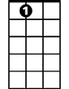

E7