**Calendar Girl (Howard Greenfield / Neil Sedaka)**

**C Am**

I love, I love, I love my calendar girl

**C Am**

Yeah, sweet calendar girl

**C Am**

I love, I love, I love my calendar girl

**F G C G7**

Each and every day of the year

**C**

January - You start the year off fine

**Am**

February - You're my little valentine

**C**

March - I'm gonna march you down the aisle

**Am**

April - You're the Easter Bunny when you smile

**Chorus:**



C

**F F7**

Yeah, yeah, my heart's in a whirl

**C Cmaj7 Am7 Cmaj7 A7**

I love, I love, I love my little calendar girl

**D7**

Every day (every day),

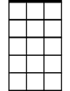

Am7

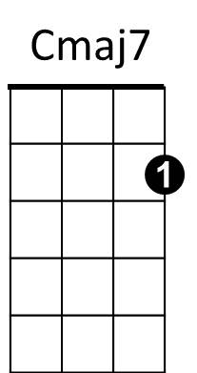 **G7 C**

Every day (every day) of the year

**F C G7**

Every day of the year

**C**

May - Maybe if I ask your Dad and Mom

**Am**

June - They'll let me take you to the Junior Prom

**BARITONE**

**C**

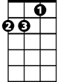

Am



F

July - Like a firecracker all aglow

C



G

**Am**

August - When you're on the beach you steal the show

**(Chorus)**

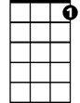

G7

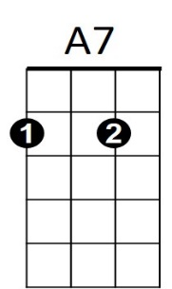 **(Instrumental verse chords)**

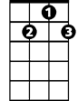

D7

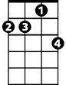

Am7

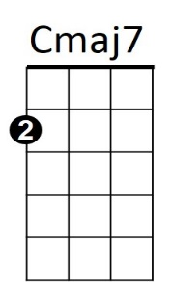

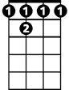

F 7

**C**

September - Light the candles at your Sweet 16

**Am**

October - Romeo and Juliet on Halloween

**C**

November - I'll give thanks that you belong to me

**Am**

December - You're the present 'neath my Christmas tree

**(Chorus)**

**(repeat to fade):**

**C Am**

I love, I love, I love my calendar girl

**C Am**

Yeah, sweet calendar girl

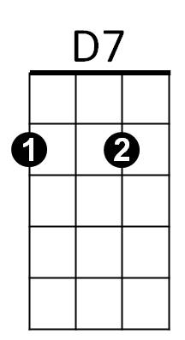



G7

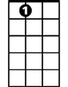

A7

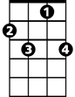

F7

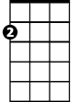

Am

F



G