**California Dreaming (John Phillips / Michelle Phillips) Key A**

**Intro: A Dm / C Bb / C A7**

**A7 Dm C Bb**

All the leaves are brown *(all the leaves are brown)*

**C A**

And the sky is gray *(and the sky is gray)*

**Bb F A Dm**

I’ve been for a walk  *(I’ve been for a walk)*

**A A7**

On a winter’s day *(on a winter’s day)*

**Dm C Bb**

I’d be safe and warm *(I’d be safe and warm)*

**C A**

If I was in L.A. *(If I was in L.A.)*

**Dm C Bb**

California dreaming *(California dreaming)*

**C A7**

On such a winter’s day

**Dm C Bb**

Stopped into a church

**C A**

I passed along the way

**Bb F A Dm**

Well I got down on my knees *(Got down on my knees)*

**Bb A7**

And I pretend to pray *(I pretend to pray)*

**Dm**

You know the preacher liked the cold,

**C Bb**

*(Preacher liked the cold)*

**C A**

He knows I’m gonna stay *(Knows I’m gonna stay)*

**Dm C Bb**

California dreaming (California dreaming)

**C A7**

On such a winter’s day

**Interlude**…**Dm Gm Dm Gm / F A Dm Bb A**

**Dm Gm Dm Gm A / Dm Gm Dm Gm A7**

**A7 Dm C Bb**

All the leaves are brown *(all the leaves are brown)*

**C A**

And the sky is gray *(and the sky is gray)*

**Bb F A Dm**

I’ve been for a walk  *(I’ve been for a walk)*

**A**

On a winter’s day *(on a winter’s day)*

**Dm C Bb**

If I didn’t tell her *(If I didn’t tell her)*

**C A A7**

I could leave today *(I could leave today)*

**Dm C Bb**

California dreaming *(California dreaming)*

**C Dm C Bb**

On such a winter’s day *(California dreaming*)

**C Dm C Bb**

On such a winter’s day (*California dreaming*)

**C Bbmaj7 Dm**

On such a winter’s da --- ay

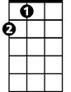

A



Bb



C

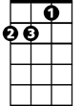

Dm

F

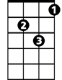

Gm

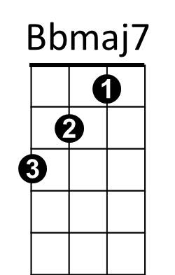

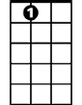

A7

**BARITONE**

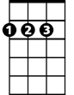

A

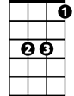

Bb

C



Dm

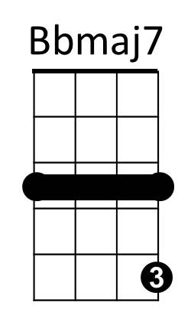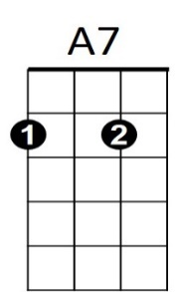

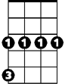

Gm



F

**California Dreaming (John Phillips / Michelle Phillips) Key D**

**Intro: D Gm / F Eb / F D7**

**D7 Gm F Eb**

All the leaves are brown *(all the leaves are brown)*

**F D**

And the sky is gray *(and the sky is gray)*

**Eb Bb D Gm**

I’ve been for a walk  *(I’ve been for a walk)*

**D D7**

On a winter’s day *(on a winter’s day)*

**Gm F Eb**

I’d be safe and warm *(I’d be safe and warm)*

**F D**

If I was in L.A. *(If I was in L.A.)*

**Gm F Eb**

California dreaming *(California dreaming)*

**F D7**

On such a winter’s day

**Gm F Eb**

Stopped into a church

**F D**

I passed along the way

**Eb Bb D Gm**

Well I got down on my knees *(Got down on my knees)*

**Eb D7**

And I pretend to pray *(I pretend to pray)*

**Gm**

You know the preacher liked the cold,

**F Eb**

*(Preacher liked the cold)*

**F D**

He knows I’m gonna stay *(Knows I’m gonna stay)*

**Gm F Eb**

California dreaming (California dreaming)

**F D7**

On such a winter’s day

**Interlude**…**Gm Cm Gm Cm / Bb D Gm Eb D**

**Gm Cm Gm Cm D / Gm Cm Gm Cm D7**

**D7 Gm F Eb**

All the leaves are brown *(all the leaves are brown)*

**F D**

And the sky is gray *(and the sky is gray)*

**Eb Bb D Gm**

I’ve been for a walk  *(I’ve been for a walk)*

**D**

On a winter’s day *(on a winter’s day)*

**Gm F Eb**

If I didn’t tell her *(If I didn’t tell her)*

**F D D7**

I could leave today *(I could leave today)*

**Gm F Eb**

California dreaming *(California dreaming)*

**F Gm F Eb**

On such a winter’s day *(California dreaming*)

**F Gm F Eb**

On such a winter’s day (*California dreaming*)

**F Ebmaj7 Gm**

On such a winter’s da --- ay



Gm



D

F



Eb

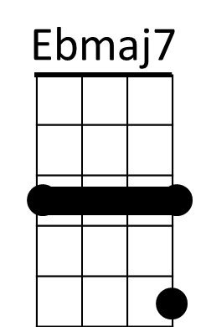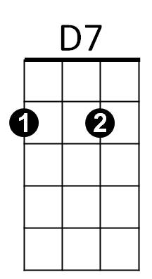



Bb



Cm

**BARITONE**

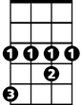

Eb



F



D



Gm

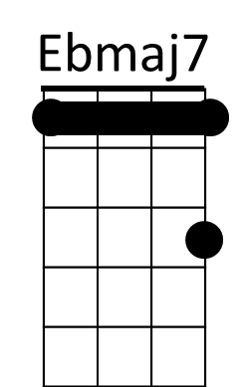

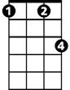

Cm

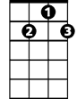

D7



Bb

**California Dreaming (John Phillips / Michelle Phillips) Key G**

**Intro: G Cm / Bb Ab / Bb G7**

**G7 Cm Bb Ab**

All the leaves are brown *(all the leaves are brown)*

**Bb G**

And the s ky is gray *(and the sky is gray)*

**Ab Eb G Cm**

I’ve been for a walk  *(I’ve been for a walk)*

**G G7**

On a winter’s day  *(on a winter’s day)*

**Cm Bb Ab**

I’d be be safe and warm *(I’d be safe and warm)*

**Bb G**

If I wa s in L.A. *(If I was in L.A.)*

**Cm Bb Ab**

California dreaming *(California dreaming)*

**Bb G7**

On such a winter’s day

**Cm Bb Ab**

Stopped into a church

**Bb G**

I passed along the way

**Ab Eb G Cm**

Well I got down on my knees *(Got down on my knees)*

**Ab G7**

And I pretend to pray *(I pretend to pray)*

**Cm**

You know the preacher liked the cold,

**Bb Ab**

*(Preacher liked the cold)*

**Bb G**

He knows I’m gonna stay *(Knows I’m gonna stay)*

**Cm Bb Ab**

California dreaming (California dreaming)

**Bb G7**

On such a winter’s day

**Interlude**…**Cm Fm Cm Fm / Eb G Cm Ab G**

**Cm Fm Cm Fm G / Cm Fm Cm Fm G7**

**G7 Cm Bb Ab**

All the leaves are brown *(all the leaves are brown)*

**Bb G**

And the sky is gray *(and the sky is gray)*

**Ab Eb G Cm**

I’ve been for a walk  *(I’ve been for a walk)*

**G**

On a winter’s day *(on a winter’s day)*

**Cm Bb Ab**

If I didn’t tell her *(If I didn’t tell her)*

**Bb G G7**

I could leave today *(I could leave today)*

**Cm Bb Ab**

California dreaming *(California dreaming)*

**Bb Cm Bb Ab**

On such a winter’s day *(California dreaming*)

**Bb Cm Bb Ab**

On such a winter’s day (*California dreaming*)

**Bb Abmaj7 Cm**

On such a winter’s da --- ay



G



Ab



Bb



Cm

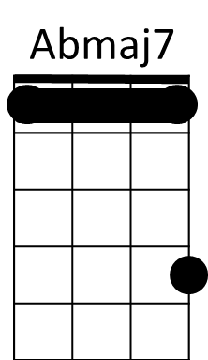



G7



Fm



Eb

**BARITONE**

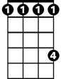

Ab



Bb



Cm



G

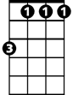

Fm

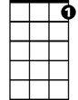

G7



Eb

