Can't Buy Me Love (Lennon-McCartney, 1964) (C)

INTRO: / 1 2 / 1  Em7 Am Em7 Am Dm G  Can't buy me lo - ove, lo - ove, can't buy me lo – ove.  C  I'll buy you a diamond ring, my friend, if it makes you feel alright.  F C  I'll get you anything, my friend, if it makes you feel alright.  G F C  'Cause I don't care too ↓ much for money, money can't buy me love.  C C  I'll give you all I've got to give, if you say you love me too  F C  I may not have a lot to give, but what I got I'll give to you  G F C  I don't care too ↓ much for money, money can't buy me love  Em7 Am C  Can't buy me lo - ove, everybody tells me so.  Em7 Am Dm G  Can't buy me lo - ove, no, no, no nooo!  C  Say you don't need no diamond rings, and I'll be satisfied  F C  Tell me that you want the kind of things that money just can't buy  G F C  I don't care too ↓ much for money, money can't buy me love  Em7 Am Em7 Am Dm G G  Can't buy me lo - ove, lo - ove, can't buy me lo – ove. ↓  Bari |  |  |  |  |  | 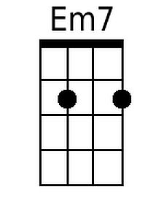
 |  |  |  |  |  | 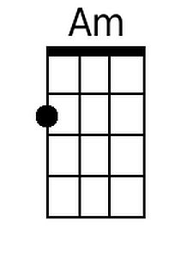
 |  |  |  |  |  | 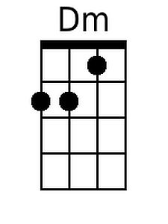
 |  |  |  |  |  | 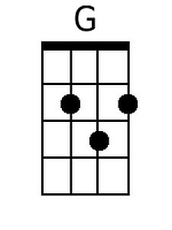
 |  |  |  |  |  | 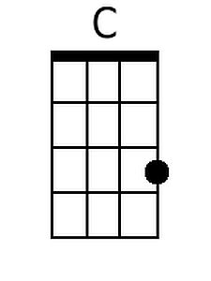
 |  |  |  |  |  | 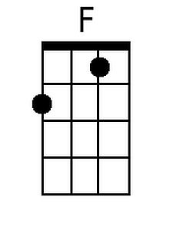
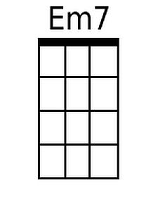 | 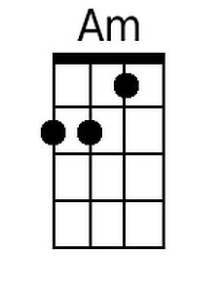 | 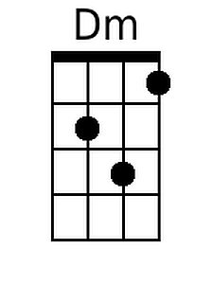 | 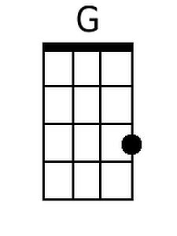 | 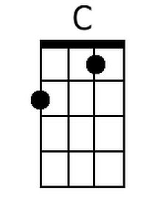 | 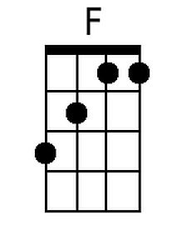

Can't Buy Me Love (Lennon-McCartney, 1964) (G)

INTRO: / 1 2 / 1  Bm7 Em Bm7 Em Am D  Can't buy me lo - ove, lo - ove, can't buy me lo - ove.  G  I'll buy you a diamond ring my friend, if it makes you feel alright  C G  I'll get you anything my friend, if it makes you feel alright  D C  'Cause I don't care too ↓ much for money  C G  Money can't buy me love  G G  I'll give you all I've got to give, if you say you love me too  C G  I may not have a lot to give, but what I got I'll give to you  D C C G  I don't care too ↓ much for money, money can't buy me love.  Bm7 Em G  Can't buy me lo - ove, everybody tells me so  Bm7 Em Am D  Can't buy me lo - ove, no, no, no nooo!  G  Say you don't need no diamond rings, and I'll be satisfied  C G  Tell me that you want the kind of things, that money just can't buy  D C G  I don't care too ↓ much for money, money can't buy me love  Bm7 Em Bm7 Em Am D D  Can't buy me lo - ove, lo - ove, can't buy me lo - ove. ↓  Bari |  |  |  |  |  | 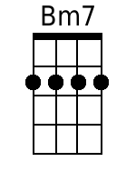
 |  |  |  |  |  | 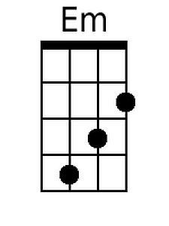
 |  |  |  |  |  | 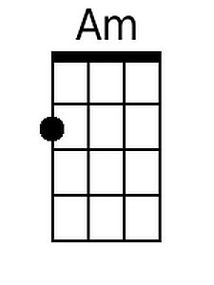
 |  |  |  |  |  | 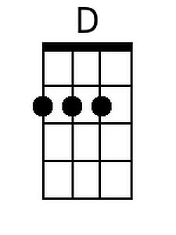
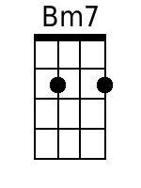 | 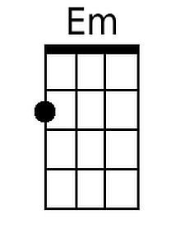 |  | 