Can't Buy Me Love (Lennon-McCartney, 1964) (C)

Intro (Single Strum): C  Em Am Em Am Dm G  Can't buy me lo - ove, lo - ove, can't buy me lo – ove.  C  I'll buy you a diamond ring, my friend, if it makes you feel alright.  F C  I'll get you anything, my friend, if it makes you feel alright.  G F F C  'Cause I don't care too ↓ much for money, money can't buy me love.  C  I'll give you all I've got to give, if you say you love me too.  F C  I may not have a lot to give, but what I got I'll give to you.  G F F C  I don't care too ↓ much for money, money can't buy me love.  Bridge  Em Am C  Can't buy me lo - ove, everybody tells me so.  Em Am Dm G  Can't buy me lo - ove, no, no, no nooo!  C  Say you don't need no diamond rings, and I'll be satisfied.  F C  Tell me that you want the kind of things that money just can't buy.  G F F C  I don't care too ↓ much for money, money can't buy me love.  Repeat From Bridge  Outro  Em Am Em Am Dm G7 C | C  Can't buy me lo - ove, lo - ove, can't buy me lo - o - ove . |  |  |  |  |  |  |  |  | 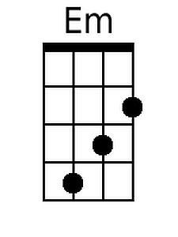
 |  |  |  |  |  |  |  |  | 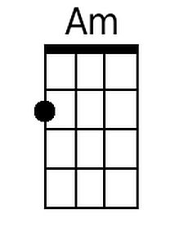
 |  |  |  |  |  |  |  |  | 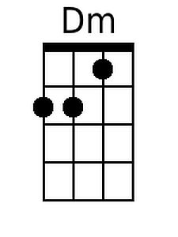
 |  |  |  |  |  |  |  |  | 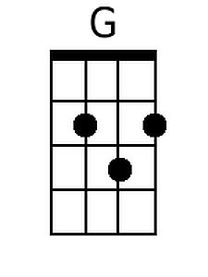
 |  |  |  |  |  |  |  |  | 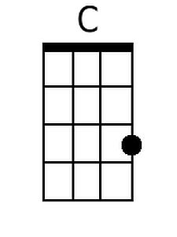
 |  |  |  |  |  |  |  |  | 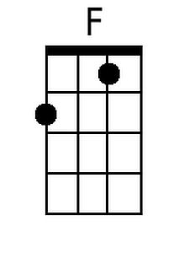
 |  |  |  |  |  |  |  |  | 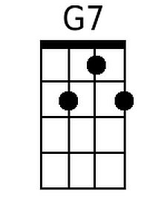
 | Bari | 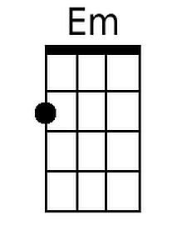 | 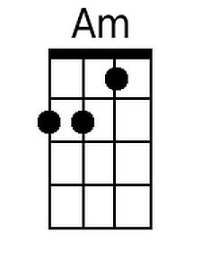 | 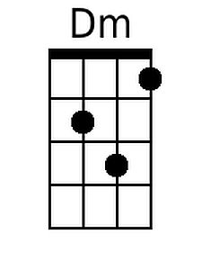 | 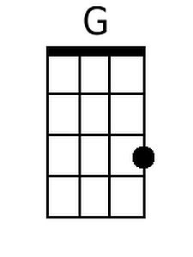 | 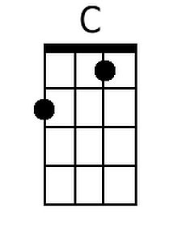 | 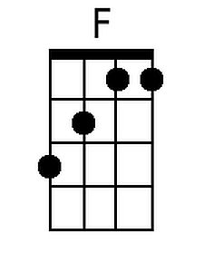 | 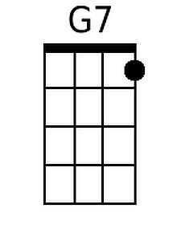
Note: Verses are in a 12-bar blues form.
Can't Buy Me Love (Lennon-McCartney, 1964) (G)

Intro (Single Strum): G  Bm Em Bm Em Am D  Can't buy me lo - ove, lo - ove, can't buy me lo - ove.  G  I'll buy you a diamond ring my friend, if it makes you feel alright.  C G  I'll get you anything my friend, if it makes you feel alright.  D C C G  'Cause I don't care too ↓ much for money, money can't buy me love.  G  I'll give you all I've got to give, if you say you love me too.  C G  I may not have a lot to give, but what I got I'll give to you.  D C C G  I don't care too ↓ much for money, money can't buy me love.  Bridge  Bm Em G  Can't buy me lo - ove, everybody tells me so  Bm Em Am D  Can't buy me lo - ove, no, no, no nooo!  G  Say you don't need no diamond rings, and I'll be satisfied  C G  Tell me that you want the kind of things, that money just can't buy  D C C G  I don't care too ↓ much for money, money can't buy me love.  Repeat From Bridge  Outro  Bm Em Bm Em Am D7 G | G  Can't buy me lo - ove, lo - ove, can't buy me lo - o - ove. |  |  |  |  |  |  |  |  | 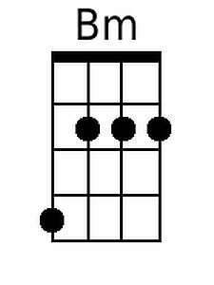
 |  |  |  |  |  |  |  |  | 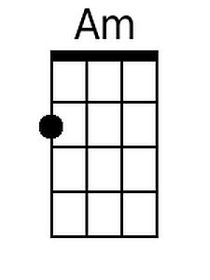
 |  |  |  |  |  |  |  |  | 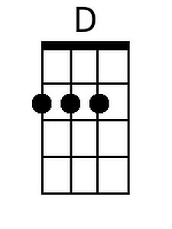
 |  |  |  |  |  |  |  |  | 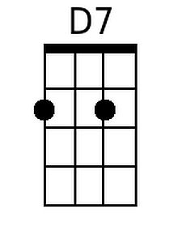
 | Bari | 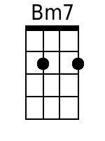 |  |  | 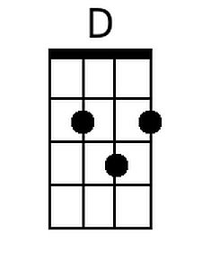 |  |  | 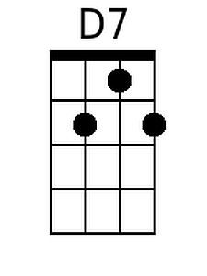

Note: Verses are in a 12-bar blues form.

