**Candle In The Wind (Elton John / Bernie Taupin) Key C**

**C**

Goodbye Norma Jean



C

**F**

Though I never knew you at all

**C**

You had the grace to hold yourself

**F**

While those around you crawled

F



**C**

They crawled out of the woodwork

**F**

And they whispered into your brain

**C**

They set you on the treadmill

**F**



G

And they made you change your name

**Chorus:**

**G G7**

And it seems to me you lived your life

**C F**

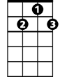

G7

Like a candle in the wind

**C F**

Never knowing who to cling to

**G**

When the rain set in

**F**

And I would have liked to have known you

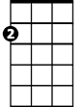

Am

**Am**

But I was just a kid

**G**

Your candle burned out long before

**F**

Your legend ever did

**F//// C / F/ C// G7**

**BARITONE**



F

C



G

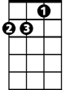

Am

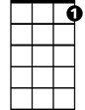

G7

**C**

Loneliness was tough

**F**

The toughest role you ever played

**C**

Hollywood created a superstar

**F**

And pain was the price you paid

**C**

Even when you died

**F**

Oh the press still hounded you

**C**

All the papers had to say

**F**

Was that Marilyn was found in the nude

**(Chorus) F//// C / F/ C// G7**

**C**

Goodbye Norma Jean

**F**

Though I never knew you at all

**C**

You had the grace to hold yourself

**F**

While those around you crawled

**C**

Goodbye Norma Jean

**F**

From the young man in the 22nd row

Who sees you as something more than

**C**

sexual

**F**

More than just our Marilyn Monroe

**(Chorus) F//// C / Gm/ C/**

**G**

Your candle burned out long before

**F F//// C / F/ C/**

Your legend ever did

**Candle In The Wind (Elton John / Bernie Taupin) Key G**

**G**

Goodbye Norma Jean



G

**C**

Though I never knew you at all

**G**

You had the grace to hold yourself

**C**

While those around you crawled

**G**



C

They crawled out of the woodwork

**C**

And they whispered into your brain

**G**

They set you on the treadmill

**C**

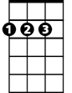

D

And they made you change your name

**Chorus:**

**D D7**

And it seems to me you lived your life

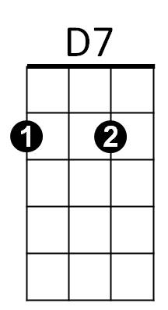 **G C**

Like a candle in the wind

**G C**

Never knowing who to cling to

**D**

When the rain set in

**C**

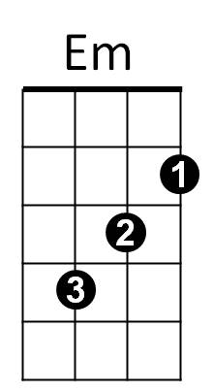And I would have liked to have known you

**Em**

But I was just a kid

**D**

Your candle burned out long before

**C**

Your legend ever did

**C//// G / C/ G// D7**

**BARITONE**



D7



D

C



G



Em

**G**

Loneliness was tough

**C**

The toughest role you ever played

**G**

Hollywood created a superstar

**C**

And pain was the price you paid

**G**

Even when you died

**C**

Oh the press still hounded you

**G**

All the papers had to say

**C**

Was that Marilyn was found in the nude

**(Chorus) C//// G / C/ G// D7**

**G**

Goodbye Norma Jean

**C**

Though I never knew you at all

**G**

You had the grace to hold yourself

**C**

While those around you crawled

**G**

Goodbye Norma Jean

**C**

From the young man in the 22nd row

Who sees you as something more than

**G**

sexual

**C**

More than just our Marilyn Monroe

**(Chorus) C//// G / C/ G/**

**D**

Your candle burned out long before

**C C//// G / C/ G/**

Your legend ever did