Candle In The Wind (Elton John, Bernie Taupin) (C)
Candle In The Wind by Elton John (Capo 2)

Intro: G F C G  C F  Goodbye Norma Jean, though I never knew you at all  C F  You had the grace to hold yourself, while those around you crawled  C F  They crawled out of the woodwork, and they whispered into your  brain  C  They set you on the treadmill, and they made you change your F  name.  Chorus  G G7 C F  And it seems to me you lived your life like a candle in the wind  C G  Never knowing who to cling to when the rain set in  F Am  And I would have liked to have known you, but I was just a kid  G F C  Your candle burned out long before your legend ever did.  C F  Loneliness was tough, the toughest role you ever played  C F  Hollywood created a superstar, and pain was the price you paid  C F  Even when you died, oh the press still hounded you  F C F  All the papers had to say was that Marilyn was found in the nude.  Chorus  C F  Goodbye Norma Jean, though I never knew you at all  C F  You had the grace to hold yourself, while those around you crawled  C F  Goodbye Norma Jean, from the young man in the 22nd row  C  Who sees you as something more than sexual,  F  more than just our Marilyn Mon-roe. Chorus  Outro  G F C  Your candle burned out long before, your legend ever did. | 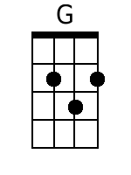 | 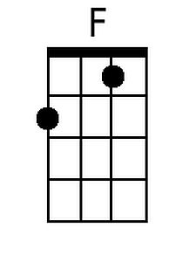
 | 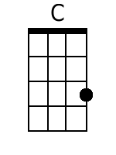 | 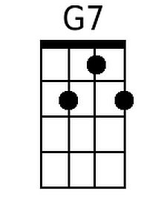
 | 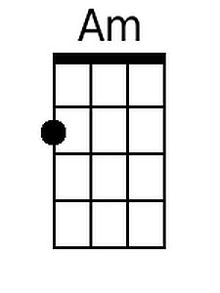
 | Baritone
 | 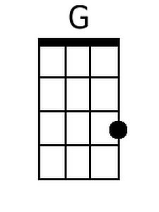 | 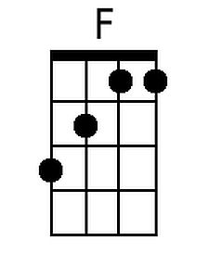
 | 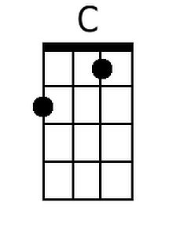 | 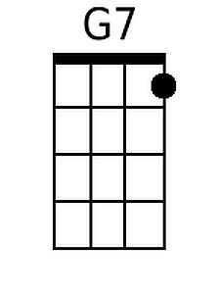
 | 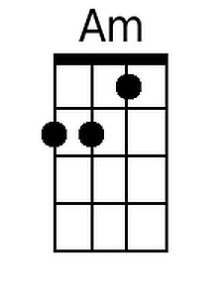

Candle In The Wind (Elton John, Bernie Taupin) (G)
Candle In The Wind by Elton John (Capo 2)

Intro: D C G D  G C  Goodbye Norma Jean, though I never knew you at all  G C  You had the grace to hold yourself, while those around you crawled  G C  They crawled out of the woodwork, and they whispered into your  brain  G  They set you on the treadmill, and they made you change your C  name.  Chorus  D D7 G C  And it seems to me you lived your life like a candle in the wind  G D  Never knowing who to cling to when the rain set in  C Em  And I would have liked to have known you, but I was just a kid  D C G  Your candle burned out long before your legend ever did.  G C  Loneliness was tough, the toughest role you ever played  G C  Hollywood created a superstar, and pain was the price you paid  G C  Even when you died, oh the press still hounded you  C G C  All the papers had to say was that Marilyn was found in the nude.  Chorus  G C  Goodbye Norma Jean, though I never knew you at all  G C  You had the grace to hold yourself, while those around you crawled  G C  Goodbye Norma Jean, from the young man in the 22nd row  G  Who sees you as something more than sexual,  C  more than just our Marilyn Mon-roe. Chorus  Outro  D C G  Your candle burned out long before, your legend ever did. | 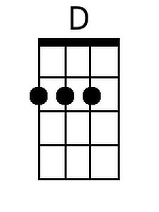
 |  | 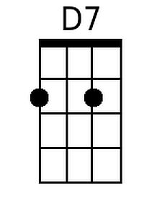
 | 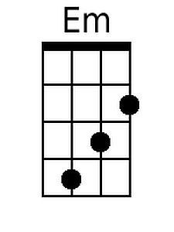
 | Baritone
 | 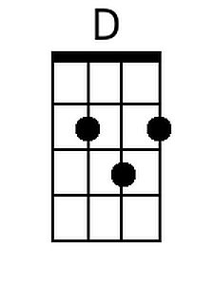
 |  | 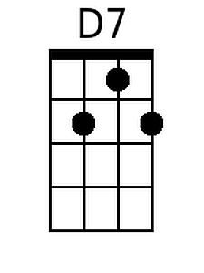
 | 