**Can’t Fight This Feeling (Kevin Cronin)**

**Intro: Chords for first line**

**C G Am**

I can't fight this feeling any longer,

**F C G**

And yet I'm still afraid to let it flow  
 **C G**

What started out as friendship

**A**

Has grown stronger  
 **Dm F G**

I only wish I had the strength to let it show

**C G Am**

I tell myself that I can't hold out forever,

**F C G**

I said there is no reason for my fear  
 **C G A**

'Cause I feel so secure when we're together  
**Dm C**

You give my life direction,

**F G**

You make everything so clear

**Bridge:**

**F**

And even as I wander,

**C**

I'm keeping you in sight  
 **F**

You're a candle in the window

**C G**

On a cold, dark winter's night  
 **F**

And I'm getting closer

**Am G F G**

Than I ever thought I might

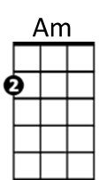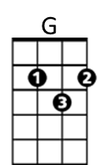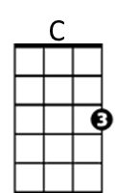

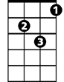

Dm

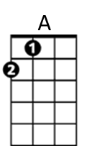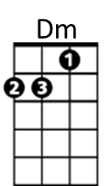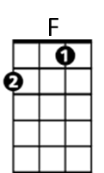



F

**Chorus:**

**F C Dm F**

And I can't fight this feeling anymore  
 **C Dm F**

I've forgotten what I started fighting for  
 **C Dm F**

It's time to bring this ship into the shore  
 **F G F G**

And throw away the oars, forever

**F C Dm F**

'Cause I can't fight this feeling anymore  
 **C Dm F**

I've forgotten what I started fighting for

**C Dm**And if I have to crawl upon the floor  
 **F Dm**

Come crashing through your door  
 **F G C F G**

Baby, I can't fight this feeling anymore

**C G Am**

My life has been such a whirlwind since I saw you,

**F C G**

I've been running round in circles in my mind  
 **C G A**

And it always seems that I'm fol~lowing you, girl  
 **Dm C**

'Cause you take me to the places

**F G**

That alone I'd never find

**(Bridge and Chorus) (Repeat chorus to finish)**

**BARITONE**

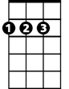

A

C

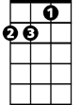

Am



G