**Car Wash Blues (Jim Croce)**

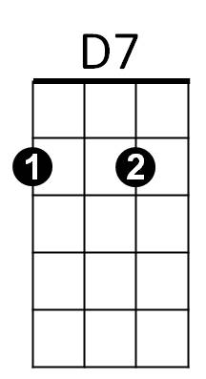**Key G**



G



C

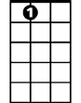

A7

**G**

Well, I just got out from the county prison,

**D7**

Doin' ninety days for non-support.

Tried to find me an executive position,

**G**

But no matter how smooth I talked

They wouldn't listen to

**G7**

The fact that I was a genius,

**C A7**

The man say, 'We got all that we can use...'

**CHORUS:**

**A7 G B7**

Now I got them steadily depressin',

**Em** **G7**

Low down mind messin',

**C D7 G**

Workin' at the car wash blues.

**G**

Well, I should be sittin' in an air conditioned

**D7**

Office In a swivel chair.

Talkin' some trash to the secretaries,

**G**

Sayin', 'Hey, now mama, come on over here.'

Instead, I'm stuck here rubbin' these fenders with

**G7**

a rag

**C A7**

And walkin' home in soggy old shoes...

**(CHORUS)**

**G C**

You know a man of my ability,

**G**

He should be smokin' on a big cigar.

**C**

But till I get myself straight

I guess I'll just have to wait

**A7 D7**

In my rubber suit rubbin' these cars.

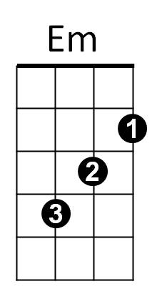

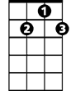

G7

**G**

Well, all I can do is a shake my head,

**D7**

You might not believe that it's true.

For workin' at this end of Niagara Falls

**G**

Is an undiscovered Howard Hughes.

So baby, don't expect to see me,

**G7**

With no double martini

**C A7**

In any high-brow societynews.

**(Chorus)**

**G B7**

Cause I got them steadily depressin',

**Em G7**

Low down mind messin',

**C D7 G**

Workin' at the car wash blues

**BARITONE**

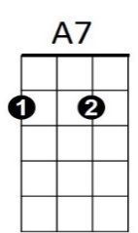

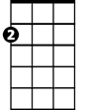

Em



G



D7

C

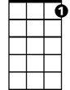

G7

B7

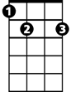

**Car Wash Blues (Jim Croce)**

F



G7



C

**Key C**

**C**

Well, I just got out from the county prison,

**G7**

Doin' ninety days for non-support.

Tried to find me an executive position,

**C**

But no matter how smooth I talked

They wouldn't listen to the fact

**C7**

That I was a genius,

**F D7**

The man say, 'We got all that we can use...'

**CHORUS:**

**D7 C E7**

Now I got them steadily depressin',

**Am C7**

Low down mind messin',

**F G7 C**

Workin' at the car wash blues.

**C**

Well, I should be sittin' in an air conditioned

**G7**

Office In a swivel chair.

Talkin' some trash to the secretaries,

**C**

Sayin', 'Hey, now mama, come on over here.'

Instead, I'm stuck here rubbin' these fenders

**C7**

with a rag

**F D7**

And walkin' home in soggy old shoes...

**(CHORUS)**

**C F**

You know a man of my ability,

**C**

He should be smokin' on a big cigar.

**F**

But till I get myself straight

I guess I'll just have to wait

**D7 G7**

In my rubber suit rubbin' these cars.



C7



Am

E7



**C**

Well, all I can do is a shake my head,

**G7**

You might not believe that it's true.

For workin' at this end of Niagara Falls

**C**

Is an undiscovered Howard Hughes.

So baby, don't expect to see me,

**C7**

With no double martini

**F D7**

In any high-brow society news.

**(Chorus)**

**C E7**

Cause I got them steadily depressin',

**Am C7**

Low down mind messin',

**F G7 C**

Workin' at the car wash blues



E7



F

C



**BARITONE**



G7



D7

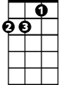

Am

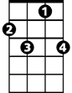

C7