**Caribbean Queen (Billy Ocean)**

**Intro: Dm C (4X)**

**Dm C Dm C Dm C Dm C**

She dashed by me in painted on jeans

**Dm C Dm C Dm C Dm C**

And all heads turned 'cause she was the dream

**Dm C Dm C Dm C Dm C**

In the blink of an eye I knew her number and her name, yeah

**Dm C Dm C Dm C Dm C**

She said I was the tiger she wanted to tame

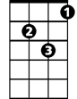

Gm

F

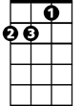

Dm



C

**Chorus:**

**Dm**

Caribbean Queen

**C Dm**

Now we're sharing the same dream



Bb

**F Gm Dm**

And our hearts they beat as one

**Bb C Dm C Dm C**

No more love on the run

**Dm C Dm C Dm C Dm C**

I lose my cool when she steps in the room

**Dm C Dm C Dm C Dm C**

And I get so excited just from her perfume

**BARITONE**

**Dm C Dm C Dm C Dm C**

C



Dm

E - lectric eyes that you can't ignore

**Dm C Dm C Dm C Dm C**

And passion burns you like never before

**Bb C**

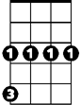

Gm



F

I was in search of a good time

**Bb C**

Just running my game

**Bb C**

Love was the furthest

**Dm C Dm C**

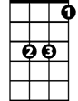

Bb

Furthest from my mind

**(Chorus) 2x**