**Cast Your Fate to the Wind (Vince Guaraldi) Key C**

**INTRO: Bb C / Bb F (2x) Bb C**

**C F**

A month of nights, a year of days.

**C Bb**

Octobers drifting into Mays.

**C F**

I set my sail when the tide comes in,

**Bb C7 F**

And I just cast my fate to the wind.

**Bb C / Bb F / Bb C**

**C F**

I shift my course along the breeze.

**C Bb**

Won't sail upwind on memories.

**C F**

The empty sky is my best friend,

**Bb C7 F**

And I just cast my fate to t he wind.

**Bb C / Bb F / Bb C**

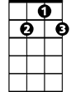

G7

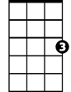

C

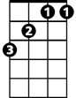

Bb

F

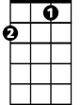

**Chorus:**

**C7 F Bb**

Time has such a way of changing

**F C7**

A man throughout the years.

**F Bb**

**BARITONE**

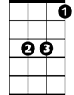

Bb

C



F

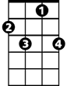

C7

And now I’m re..arranging

**F G7**

My life through all my tears..

**F C7 F C7 G7**

A-lo - ne...a-lo - ne.- a-lone…

**C F**

There never was, there couldn't be,

**C Bb**

A place in time for men like me..

**C F**

Who'd drink the dark and laugh at day,

**Bb C7 F**

And let their wildest dreams blow away.

**Bb C / Bb F / Bb C**

**(Chorus)**

**C F**

So now I’m old, I’m wise, I’m smart,

**C Bb**

I’m just a man with half a heart

**C F**

I wonder how it might have been

**Bb C7 F**

Had I not cast my fate to the wind

**Bb C / Bb F / Bb C**

**Bb C7 F**

Had I not cast my fate to the wind

**Bb C / Bb F / Bb C / Bb F**

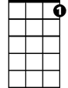

C7



G7

**Cast Your Fate to the Wind (Vince Guaraldi) Key G**

**INTRO: F G / F C (2x) F G**

**G C**

A month of nights, a year of days.

**G F**

Octobers drifting into Mays.

**G C**

I set my sail when the tide comes in,

**F G7 C**

And I just cast my fate to the wind.

**F G / F C / F G**

**G C**

I shift my course along the breeze.

**G F**

Won't sail upwind on memories.

**G C**

The empty sky is my best friend,

**F G7 C**

F



And I just cast my fate to the wind.

**F G / F C / F G**

**Chorus:**

**G7 C F**

Time has such a way of changing

**C G7**

A man throughout the years.



F

**C F**

And now I’m re..arranging

**C**  **D7**

My life through all my tears..

**C G7 C G7 D7**

A-lo - ne...a-lo - ne.- a-lone…

**G C**

There never was, there couldn't be,

**G F**

A place in time for men like me..

**G C**

Who'd drink the dark and laugh at day,

**F G7 C**

And let their wildest dreams blow away.

**F G / F C / F G**

**(Chorus)**

**G C**

So now I’m old, I’m wise, I’m smart,

**G F**

I’m just a man with half a heart

**G C**

I wonder how it might have been

**F G7 C**

Had I not cast my fate to the wind

**F G / F C / F G**

**F G7 C**

Had I not cast my fate to the wind

**F G / F C / F G / F G**



G

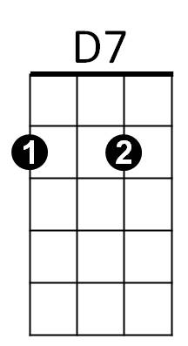



C



G7

**BARITONE**



D7

C



G



G7