**Catch the Wind (Donovan Leitch)**

**Intro: C F G C G7**

**C F**

In the chilly hours and minutes

**C F**

Of uncertainty, I want to be

**C F G C G**

In the warm hold of your loving mind

**C F**

To feel you all around me

**C F**

And to take your hand along the sand

**C**

Ah, but I may as well

**F G C F G**

Try and catch the wind

**C F**

When sundown pales the sky

**C F**

I want to hide a while behind your smile

**C F**

F



C

And everywhere I'd look,

**G C G**

your eyes I'd find.

**C F**

For me to love you now

**C**

Would be the sweetest thing,

**F**

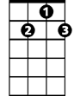

D7

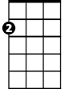

Em

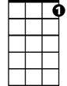

G7



G

C



**BARITONE**



F

'twould make me sing

**C**

Ah, but I may as well

**F G C C7**

Try and catch the wind

**F Em**

Deedee dee dee, dee dee deedee

**F D7**

Dee dee deedee, dee dee deedee

**G G7**

Dee de deeee

**C F**

When rain has hung the leaves with tears

**C F**

I want you near to kill my fears

**C F G C G**

To help me to leave all my blues behind

**C F**

For standing in your heart

**C F**

Is where I want to be and long to be

**C**

Ah, but I may as well

**F G C F G**

Try and catch the wind

**C**

Ah, but I may as well

**F G C F G C**

Try and catch the wind

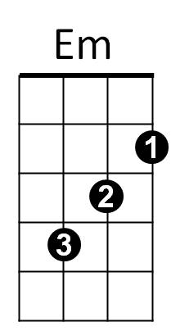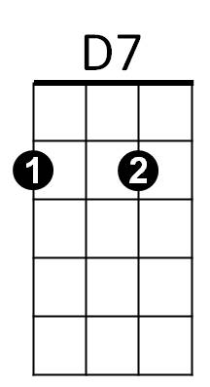



G



G7

**Catch the Wind (Donovan Leitch)**

**Intro: G C D G D7**

**G C**

In the chilly hours and minutes

**G C**

Of uncertainty, I want to be

**G C D G D**

In the warm hold of your loving mind

**G C**

To feel you all around me

**G C**

And to take your hand along the sand

**G**

Ah, but I may as well

**C D G C D**

Try and c atch the wind

**G C**

When sundown pales the sky

**G C**

I want to hide a while behind your smile

**G C**



G



C

And everywhere I'd look,

**D G D**

your eyes I'd find.

**G C**

For me to love you now

**G**

Would be the sweetest thing,

**C**

**BARITONE**

'twould make me sing

C



G

**G**

Ah, but I may as well

**C D G G7**

Try and catch the wind

**C Bm**

Deedee dee dee, dee dee deedee

**C A7**

Dee dee deedee, dee dee deedee

**D D7**

Dee de deeee

**G C**

When rain has hung the leaves with tears

**G C**

I want you near to kill my fears

**G C D G D**

To help me to leave all my blues behind

**G C**

For standing in your heart

**G C**

Is where I want to be and long to be

**G**

Ah, but I may as well

**C D G C D**

Try and catch the wind

**G**

Ah, but I may as well

**C D G C D G**

Try and catch the wind



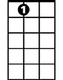

A7

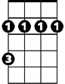

Bm

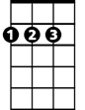

D

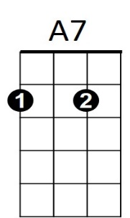

Bm

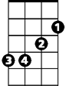

D7



D