**Cat's in the Cradle (Sandy Chapin / Harry Chapin)**

**A C**

A child arrived just the other day

**D A**

He came to the world in the usual way

**A C**

But there were planes to catch and bills to pay

**D A**

He learned to walk while I was away

**G**

And he was ta lkin’ 'fore I knew it

And as he grew he'd say

**C G A**

I'm gonna be like you, dad

**C Cmaj7 A**

You know I'm gonna be like you

**Chorus:**

**A G**

And the cat’s in the cradle and the silver spoon

**C D**

Little boy blue and the man in the moon

**A G**

When you coming home Dad, I don't know when

**C A**

But we'll get together then

**C A**

You know we'll have a good time then.

**A C**

My son turned ten just the other day

**D A**

He said “Thanks for the ball. dad, c'mon let's play

**A C**

Can you teach me to throw, I said "not today;

**D A**

I got a lot to do", he said "that's okay"

**G**

And, he walked away

But his smile never dimmed, he said

**C G A**

"I'm gonna be like him, yeah

**C Cmaj7 A**

You know I'm gonna be like him"

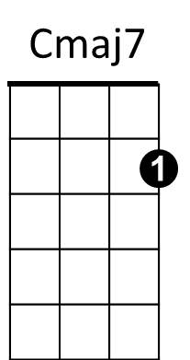**(Chorus)**



C

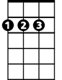

D



G

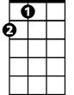

A

**A C**

Well, he came home college just the other day

**D A**

So much like a man, I just had to say

**A C**

"Son I'm proud of you, can you sit for a while?"

**D A**

He shook his head and he said with a smile

**G**

"What I'd really like Dad is to borrow the car keys.

**C G A**

See you later, can I have them please?"

**(Chorus)**

**C Cmaj7 G A C G D A**

**A C**

I've long since retired, my son's moved away

**D A**

I called him up just the other day

**C**

I said "I'd like to see you if you don't mind"

**D A**

He said "I'd love to dad if I could find the time"

**G**

You see, my new job's a hassle

And the kids have the flu

**C G A**

But it's sure nice talkin' to you dad

**C Cmaj7 A**

It's been sure nice talkin' to you

**G**

And as I hung up the phone it occurred to me

**C G A**

He'd grown up just like me

**C Cmaj7 A**

My boy was just like me

**(Chorus) (extend last line)**

**BARITONE**

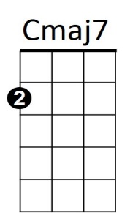



G



D



A

C



**Cat's in the Cradle (Sandy Chapin / Harry Chapin)**

**C Eb**

A child arrived just the other day

**F C**

He came to the world in the usual way

**Eb**

But there were planes to catch and bills to pay

**F C**

He learned to walk while I was away

**Bb**

And he was talkin’ 'fore I knew it

And as he grew, he'd say

**Eb Bb C**

I'm gonna be like you, dad

**Eb Ebmaj7 C**

You know I'm gonna be like you

**Chorus:**

**C Bb**

And the cat’s in the cradle and the silver spoon

**Eb F**

Little boy blue and the man in the moon

**C Bb**

When you coming home Dad, I don't know when

**Eb C**

But we'll get together then

**Eb C**

You know we'll have a good time then.

**C Eb**

My son turned ten just the other day

**F C**

He said “Thanks for the ball. dad, c'mon let's play

**C Eb**

Can you teach me to throw, I said "not today;

**F C**

I got a lot to do", he said "that's okay"

**Bb**

And, he walked away

But his smile never dimmed, he said

**Eb Bb C**

"I'm gonna be like him, yeah

**Eb Ebmaj7 C**

You know I'm gonna be like him"

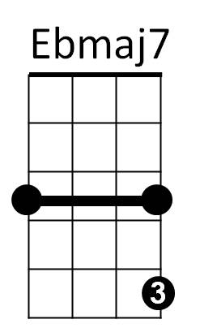**(Chorus)**



Bb

F

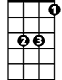

Eb



C

**C Eb**

Well, he came home from college just the other day

**F C**

So much like a man, I just had to say

**C Eb**

"Son I'm proud of you, can you sit for a while?"

**F C**

He shook his head and he said with a smile

**Bb**

"What I'd really like Dad is to borrow the car keys.

**Eb Bb C**

See you later, can I have them please?"

**(Chorus)**

**Eb Ebmaj7 Bb C Eb Bb F C**

**C Eb**

I've long since retired, my son's moved away

**F C**

I called him up just the other day

**Eb**

I said "I'd like to see you if you don't mind"

**F C**

He said "I'd love to dad if I could find the time"

**Bb**

You see, my new job's a hassle

And the kids have the flu

**Eb Bb C**

But it's sure nice talkin' to you dad

**Eb Ebmaj7 C**

It's been sure nice talkin' to you

**Bb**

And as I hung up the phone it occurred to me

**Eb Bb C**

He'd grown up just like me

**Eb Ebmaj7 C**

My boy was just like me

**(Chorus) (extend last line)**

**BARITONE**

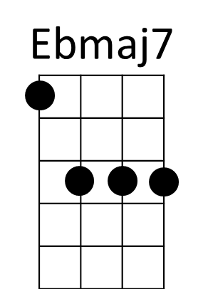

C

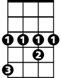

Eb



F



Bb

**Cat's in the Cradle (Sandy Chapin / Harry Chapin)**

**G Bb**

A child arrived just the other day

**C G**

He came to the world in the usual way

**G Bb**

But there were planes to catch and bills to pay

**C G**

He learned to walk while I was away

**F**

And he was talki n’ 'fore I knew it

And as he grew he'd say

**Bb F G**

I'm gonna be like you, dad

**Bb Bbmaj7 G**

You know I'm gonna be like you

**Chorus:**

**G F**

And the cat’s in the cradle and the silver spoon

**Bb C**

Little boy blue and the man in the moon

**G F**

When you coming home Dad, I don't know when

**Bb G**

But we'll get together then

**Bb G**

You know we'll have a good time then.

**G Bb**

My son turned ten just the other day

**C G**

He said “Thanks for the ball. dad, c'mon let's play

**G Bb**

Can you teach me to throw, I said "not today;

**C G**

I got a lot to do", he said "that's okay"

**F**

And he, he walked away

But his smile never dimmed, he said

**Bb F G**

"I'm gonna be like him, yeah

**Bb Bbmaj7 G**

You know I'm gonna be like him"

**(Chorus)**



Bb



G

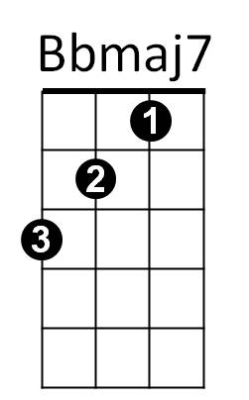

F



C

**G Bb**

Well, he came home college just the other day

**C G**

So much like a man, I just had to say

**G Bb**

"Son I'm proud of you, can you sit for a while?"

**C G**

He shook his head and he said with a smile

**F**

"What I'd really like Dad is to borrow the car keys.

**Bb F G**

See you later, can I have them please?"

**(Chorus)**

**Bb Bbmaj7 F G Bb F C G**

**G Bb**

I've long since retired, my son's moved away

**C G**

I called him up just the other day

**Bb**

I said "I'd like to see you if you don't mind"

**C G**

He said "I'd love to dad if I could find the time"

**F**

You see, my new job's a hassle

And the kids have the flu

**Bb F G**

But it's sure nice talkin' to you dad

**Bb Bbmaj7 G**

It's been sure nice talkin' to you

**F**

And as I hung up the phone it occurred to me

**Bb F G**

He'd grown up just like me

**Bb Bbmaj7 G**

My boy was just like me

**(Chorus) (extend last line)**

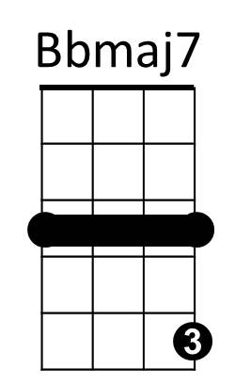

**BARITONE**



G



Bb



F

C

