**Centerfield (John Fogerty)**

**Intro: F G / C F / (3x) F Em Dm G C C C C C**

**C F C**

Well, beat the drum and hold the phone - the sun came out today!

**Am G**

We’re born again, there’s new grass on the field.

**C F C**

A-roundin’ third, and headed for home, it’s a brown-eyed handsome man;

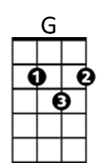 **F G C**

F



Anyone can understand the way I feel.

**Chorus:**

**C F C**

Oh, put me in, coach - I’m ready to play - today;

**F Em**

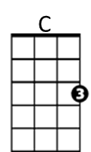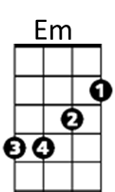Put me in, coach - I’m ready to play - today;

**Dm G C**

Look at me, I can be centerfield.

**C F C**

Well I spent some time in the Mudville nine watchin’ it from the bench;

**Am G**

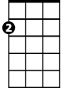

Am

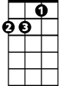

Dm

You know I took some lumps when the Mighty Case struck out.

**C F C**

So say hey, Willie, tell Ty Cobb - and Joe DiMaggi-o;

**F G C**

Don’t say "it ain’t so", you know the time is now.

**(Chorus)**

**C F C**

**BARITONE**

Got a beat-up glove, a homemade bat, and brand-new pair of shoes;

**Am G**



G



F

You know I think it’s time to give this game a ride.

**C F C**

Just to hit the ball and touch ’em all - a moment in the sun;

**F G C**

(pop) It’s gone and you can tell that one goodbye!



Am



Em

C



**Chorus x2**

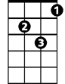

Dm