Charade (Henry Mancini & Johnny Mercer) (Am)
Simplified Version

Am E7  When we played our charade We were like children posing  E7 E7#5 E7 - Am  Playing at games, acting out names Guessing the parts we played  Am E7  Oh what a hit we made We came on next to closing  E7 E7#5 E7 Am Am7  Best on the bill, lovers until Love left the mas - quer- ade  Bridge:  Dm C Dm C  Fate seemed to pull the strings I turned and you were gone  Dm C Dm E7  While from the darkened wings The music box played on  Am E7  Sad little serenade Song of my heart's composing  E7 E7#5 E7 Am  I hear it still, I always will Best on the bill, Cha-rade  Note:  E7 1202  E7#5 1203 (just add pinky on 3rd fret) |  |  |  |  |  |  | 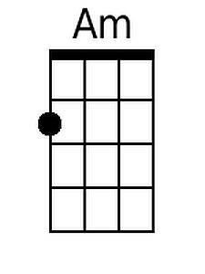
 |  |  |  |  |  |  | 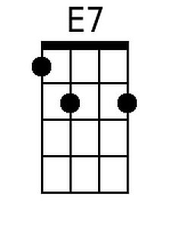
 |  |  |  |  |  |  | 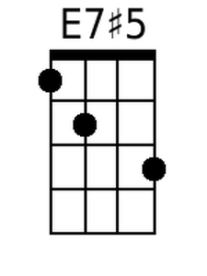
 |  |  |  |  |  |  | 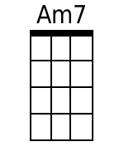
 |  |  |  |  |  |  | 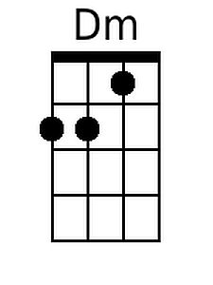
 |  |  |  |  |  |  | 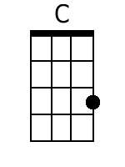
Baritone
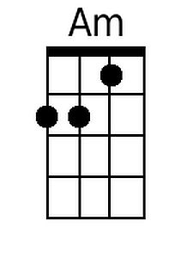 | 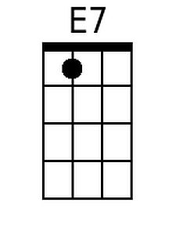 | 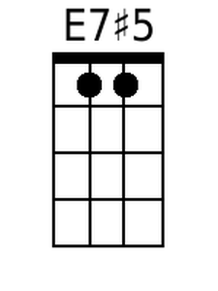 | 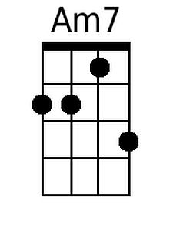 | 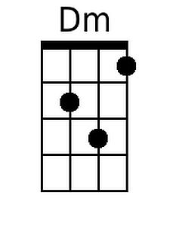 | 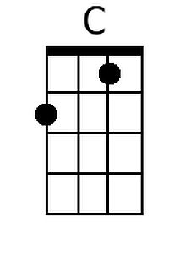

Charade (Henry Mancini & Johnny Mercer) (Dm)
Simplified Version

Dm A7
When we played our charade We were like children posing
A7 A7#5 A7 - Dm
Playing at games, acting out names Guessing the parts we played

Dm A7
Oh what a hit we made We came on next to closing
A7 A7#5 A7 Dm Dm7
Best on the bill, lovers until Love left the mas - quer - ade

Bridge:
Gm F Gm F
Fate seemed to pull the strings I turned and you were gone
Gm F Gm A7
While from the darkened wings The music box played on

Dm A7
Sad little serenade Song of my heart's composing
A7 A7#5 A7 Dm
I hear it still, I always will Best on the bill, Cha-rade

 |  |  |  |  |  |  | 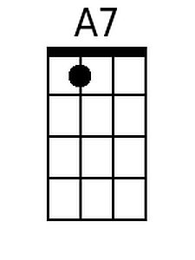
 |  |  |  |  |  |  | 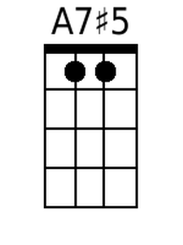
 |  |  |  |  |  |  | 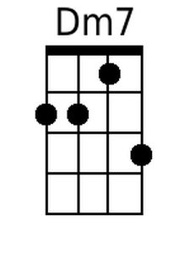
 |  |  |  |  |  |  | 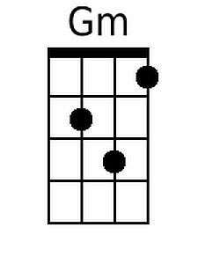
 |  |  |  |  |  |  | 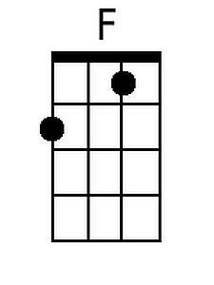
Baritone
 | 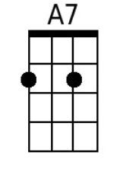 | 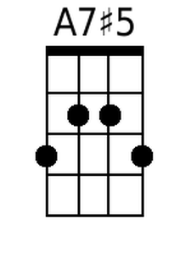 | 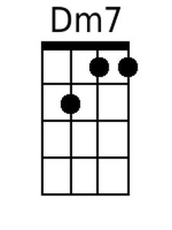 | 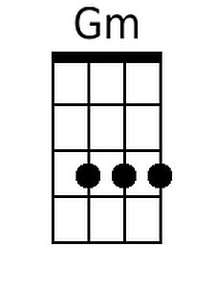 | 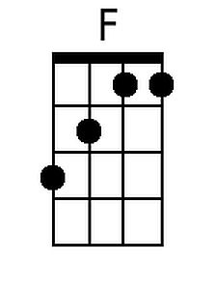

Charade (Henry Mancini & Johnny Mercer) (Em)
Simplified Version

Em B7  When we played our charade We were like children posing  B7 B7#5 B7 - Em  Playing at games, acting out names Guessing the parts we played  Em B7  Oh what a hit we made We came on next to closing  B7 B7#5 B7 Em Em7  Best on the bill, lovers until Love left the mas - quer - ade  Bridge:  Am G Am G  Fate seemed to pull the strings I turned and you were gone  Am G Am B7  While from the darkened wings The music box played on  Em B7  Sad little serenade Song of my heart's composing  B7 B7#5 B7 Em  I hear it still, I always will Best on the bill, Cha-rade |  |  |  |  |  |  | 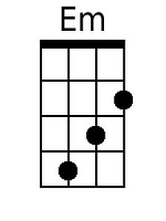
 |  |  |  |  |  |  | 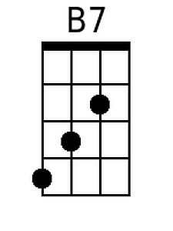
 |  |  |  |  |  |  | 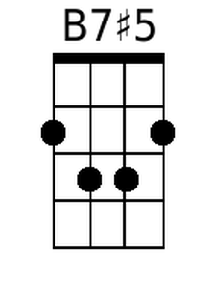
 |  |  |  |  |  |  | 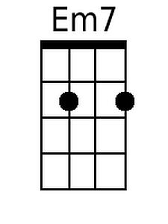
 |  |  |  |  |  |  | 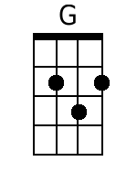
Baritone
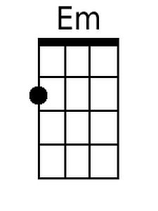 | 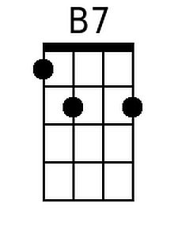 | 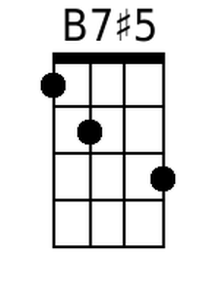 | 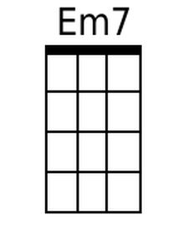 |  | 