**Cheers Theme (Gary Portnoy / Judy Hart Angelo) Key C**

**Intro: C G 2x**

**C G**

Making your way in the world today

**C G**

Takes everything you've got

**C G**

Taking a break from all your worries

**C G**

Sure would help a lot

**Gm A7 Dm G**

Wouldn't you like to get away?

**C G**

All those nights when you got no lights,

**C G**

The ch eck is in the mail

**C G**

And your little angel

**C G**

Hung the cat up by its' tail

**Gm A7 Dm**

And your third fiance didn't show

**G F C**

Somet imes you wanna go

**C Bb F G**

Where everybody knows your name

**C Bb F G**

And they're always glad you came

**Em F**

You wanna be where you can see

**Em F**

Our troubles are all the same

**Em**

You wanna go where

**F G C**

Everybody knows your name

**C G / C G**

**BARITONE**

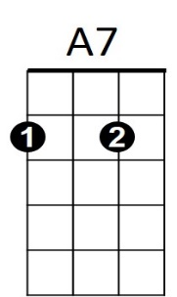

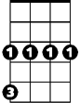

Gm



G

C



**C G**

You roll out of bed, Mr. Coffee's dead,

**C G**

The morning's looking bright

**C G**

And your shrink ran off to Europe,

**C G**

And didn't even write

**Gm A7 Dm**

And your husband wants to be a girl

**G F C**

Be glad there's one place in the world

**C Bb F G**

Where everybody knows your name

**C Bb F G**

And they're always glad you came

**Em F**

You wanna be where people know

**Em F**

People are all the same

**Em**

You wanna go where

**F G C**

Everybody knows your name

**C G / C G / C**

Em

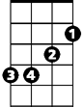

F

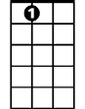

A7



G

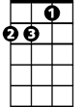

Dm



C

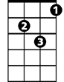

Gm



Bb



F

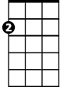

Em

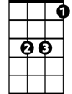

Bb



Dm

**Cheers Theme (Gary Portnoy / Judy Hart Angelo) Key F**

**Intro: F C 2X**

**F C**

Making your way in the world today

**F C**

takes everything you've got

**F C**

Taking a break from all your worries

**F C**

Sure would help a lot

**Cm D7 Gm C**

Wouldn't you like to get away?

**F C**

All those nights when you got no lights,

**F C**

The check is in the mail

**F C**

And your little angel

**F C**

Hung the cat up by its' tail

**Cm D7 Gm**

And your third fiance didn't show

**C Bb F**

Sometimes you wanna go

**F Eb Bb C**

F



Where everybody knows your name

**F Eb Bb C**

And they're always glad you came

**Am Bb**

You wanna be where you can see

**Am Bb**

Our troubles are all the same



Gm

**Am**

You wanna go where

**Bb C F**

Everybody knows your name

**F C / F C**

**BARITONE**

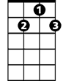

D7

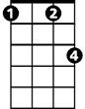

Cm



F

C



**F C**

You roll out of bed, Mr. Coffee's dead,

**F C**

The morning's looking bright

**F C**

And your shrink ran off to Europe,

**F C**

And didn't even write

**Cm D7 Gm**

And your husband wants to be a girl

**C Bb F**

Be glad there's one place in the world

**F Eb Bb C**

Where everybody knows your name

**F Eb Bb C**

And they're always glad you came

**Am Bb**

You wanna be where people know

**Am Bb**

People are all the same

**Am**

You wanna go where

**Bb C F**

Everybody knows your name

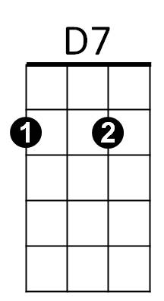**F C / F C / C**



Cm



C



Am



Eb



Bb

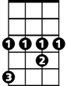

Eb



Am



Gm



Bb

**Cheers Theme (Gary Portnoy / Judy Hart Angelo) Key G**

**Intro: G D 2X**

**G D**

Making your way in the world today

**G D**

takes everything you've got

**G D**

Taking a break from all your worries

**G D**

Sure would help a lot

**Dm E7 Am D**

Wouldn't you like to get away?

**G D**

All those nights when you got no lights,

**G D**

The check is in the mail

**G D**

And your little angel

**G D**

Hung the cat up by its' tail

**Dm E7 Am**

And your third fiance didn't show

**D C G**

Sometimes you wanna go

**G F C D**

Where everybody knows your name

**G F C D**

And they're always glad you came

**Bm C**

You wanna be where you can see

**Bm C**

Our troubles are all the same

**Bm**

You wanna go where

**C D G**

Everybody knows your name

**G D / G D**

**BARITONE**



E7



Dm



G



D

**G D**

You roll out of bed, Mr. Coffee's dead,

**G D**

The morning's looking bright

**G D**

And your shrink ran off to Europe,

**G D**

And didn't even write

**Dm E7 Am**

And your husband wants to be a girl

**D C G**

Be glad there's one place in the world

**G F C D**

Where everybody knows your name

**G F C D**

And they're always glad you came

**Bm C**

You wanna be where people know

**Bm C**

People are all the same

**Bm**

You wanna go where

**C D G**

Everybody knows your name

**G D / G D / G**

E7

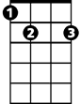

G



Dm

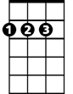

D



Am

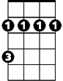

Bm



C

F



Am

Bm



F

C

