Cheeseburger in Paradise (Jimmy Buffett) (C)

Intro: | Em - - D (3x) | G (Hold)  C D G  Tried to amend my carnivorous habits  C D G  Made it nearly seventy days  C D G  Losin' weight without speed, eatin' sunflower  A D seeds  Drinkin' lots of carrot juice and soakin' up rays.  C D G  But at night I'd have these wonderful dreams,  C D Em  Some kind of sensuous treat  C G C G  Not zucchini, fettucini or bulgar wheat,  C G D G  But a big warm bun and a huge hunk of meat.  Chorus  C D G  Cheeseburger in paradise  C D G  Heaven on earth with an onion slice.  C D G  Not too particular, not too precise, I'm just a -  C D G  Cheeseburger in paradise.  | Em - - D (3x) | G (Hold) |  |  |  | C D G  Heard about the old-time sailor men  C D G  They eat the same thing again and again  C D G  Warm beer and bread they said could raise the  A D dead  Well, it reminds me of the menu at a Holiday Inn  C D G  But times have changed for sailors these days  C D Em  When I'm in port I get what I need.  C G C G  Not just Havanas or bananas or daiquiris  C G D G  But that American creation on which I feed.  Chorus  | Em - - D (3x) | G (Hold)  (A Capella)  I like mine with lettuce and tomato  Heinz 57 and french fried potatoes  Big kosher pickle and a cold draft beer  Well, good God Almighty, which way do I steer?  For my - Chorus  Outro  C D G  Cheeseburger in paradise (2x)  | Em - - D (3x) | G (Hold)
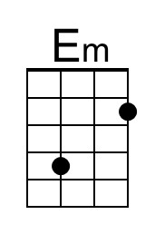 | 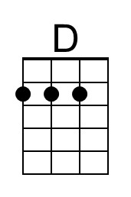 | 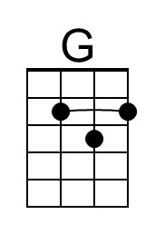 | 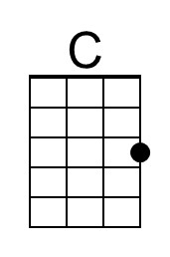 | 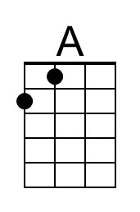
 |  | Bari | 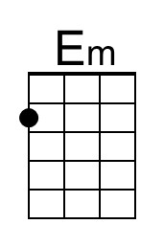 | 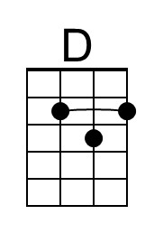 | 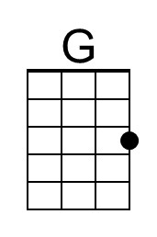 | 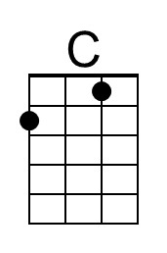 | 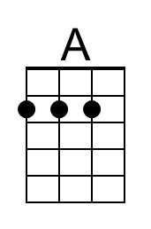

Cheeseburger in Paradise (Jimmy Buffett) (G)

Intro | Bm - - A (3x) | D (Hold)  G A D  Tried to amend my carnivorous habits  G A D  Made it nearly seventy days  G A D  Losin' weight without speed, eatin' sunflower  E A seeds  Drinkin' lots of carrot juice and soakin' up rays.  G A D  But at night I'd have these wonderful dreams,  G A Bm  Some kind of sensuous treat  G D G D  Not zucchini, fettucini or bulgar wheat,  G D A D  But a big warm bun and a huge hunk of meat.  Chorus  G A D  Cheeseburger in paradise  G A D  Heaven on earth with an onion slice  G A D  Not too particular, not too precise, I'm just a -  G A D  Cheeseburger in paradise  | Bm - - A | D (Hold) |  |  |  | G A D  Heard about the old-time sailor men  G A D  They eat the same thing again and again  G A D  Warm beer and bread they said could raise the  E A dead  Well, it reminds me of the menu at a Holiday Inn  G A D  But times have changed for sailors these days  G A Bm  When I'm in port I get what I need.  G D G D  Not just Havanas or bananas or daiquiris  G D A D  But that American creation on which I feed.  Chorus  | Bm - - A (3x) | D (Hold)  (A Capella)  I like mine with lettuce and tomato  Heinz 57 and french fried potatoes  Big kosher pickle and a cold draft beer  Well, good God Almighty, which way do I steer?  For my - Chorus  Outro  G A D  Cheeseburger in paradise (2x)  | Bm - - A (3x) | D (Hold)
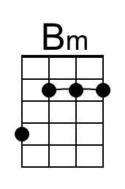 |  |  |  | 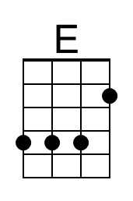
 |  | Bari | 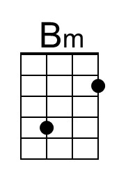 |  |  |  | 