**Christmas All Over Again (Tom Petty)**

**Key F**

**Intro: F Dm Gm C x2**

**F Dm Gm C**

Well it’s Christmas time again.

**F Dm Gm C**

Decorations are all hung by the fire

**Gm C Gm A7**

Everybody's singing, all the bells are ringing out

**F Dm F Dm Gm C**

And it's Christmas all o - ver again yea again

**F Dm Gm C**

Long distance rel - a - tives

**F Dm Gm C**

Haven't seen 'em in a long, long time

**Gm C Gm A7**

Yeah, I kind of missed 'em, I just don't wanna kiss 'em, no

**F Dm F Dm Gm C**

And it's Christmas all o - ver again yea again

**Gm C Gm C**

And all over town, Little kids gon’ get down.

**Bb**

And Christmas is a rocking time, put your body next to mine,

**G C**

Underneath the mistletoe we go, we go

**(First two lines of verse melody)**

**BARITONE**

**Gm C Gm A7**

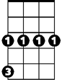

Gm

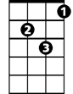

Dm



F

Everybody's singing, all the bells are ringing out

**F Dm F Dm Gm C**

And it's Christmas all o - ver again yea again

**Gm C Gm C**

And right down our block, little kids start to rock.

**Bb**



G

C

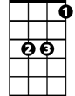

Bb

And Christmas is a rocking time, put your body next to mine,

**G C**

Underneath the mistletoe we go, we go

**F Dm Gm C**

Merry Christmas time come and find you

**F Dm Gm C**

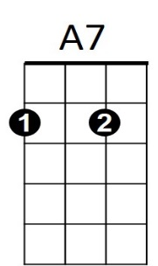Happy and there by your fire,

**Gm C Gm A7**

I hope you have a good one, I hope momma gets her shoppin' done

**F Dm F Dm Gm C**

And it's Christmas all o - ver again

**F Dm F Dm Gm C**

Baby it's Christmas all o – ver again yea again

**F Dm F Dm Gm C F**

And it's Christmas all o - ver again yea again