Christmas Don’t Be Late
C24 C
Ross Bagdasarian (as "David Seville"), 1958 (¾ Time)
Christmas Don’t Be Late by Alvin & the Chipmunks (winning 3 Grammy Awards in 1958)

Intro* | C G7 | C G7 | [Alternate Intro: Chords for last line of verse]

C C6 G7
Christmas, Christmas time is near,
C6
Time for toys and time for cheer.
Dm G7 Dm G7
We've been good, but we can't last,
Dm G7 C C6
Hurry Christmas, hurry fast.
C C6 C C6
Want a plane that loops the loop,
___________________________________
│ C7 F
│ 1. Me, I want a Hula-Hoop.
│ F Fm C A7
│ We can hardly stand the wait,
│ Dm G7 C G7
│ Please Christmas, don't be late. (Repeat from Top)

___________________________________
│ C7 F
│ 2. I STILL want a Hula-Hoop!
│ F Fm C A7
│ We can hardly stand the wait,
│ Dm G7 C G7
│ Please Christmas, don't be late.
│ F Fm C A7
│ We can hardly stand the wait,
│ Dm G7 C G7 C G7 C G7 C
│ Please Christmas, don't be late

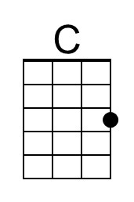 | 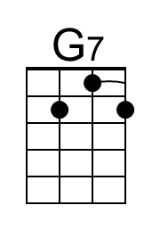 | 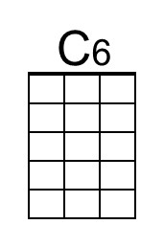 | 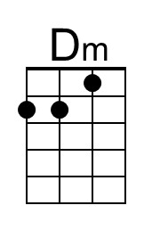 | 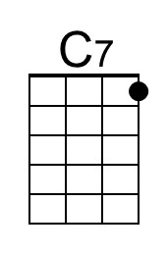 | 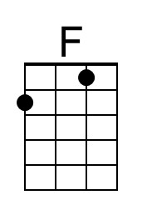 | 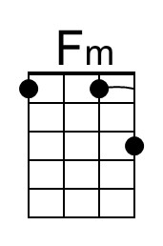 | 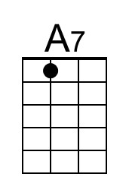
Baritone | 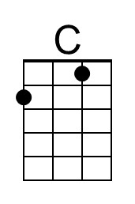 | 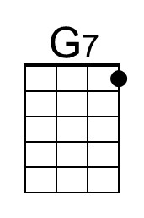 | 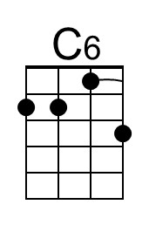 | 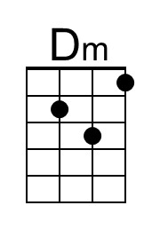 | 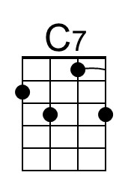 | 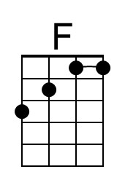 | 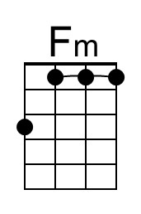 | 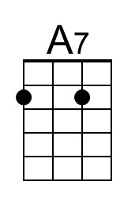

* Suggested chord strumming pattern: ||: C _ C C C _ G7 G7 :||
↓ ↑ ↓ ↑ ↓ ↑

Christmas Don’t Be Late
C24 G
Ross Bagdasarian (as "David Seville"), 1958 (¾ Time)
Christmas Don’t Be Late by Alvin & the Chipmunks (winning 3 Grammy Awards in 1958)

Intro* | G D7 | G D7 | [Alternate Intro: Chords for last line of verse]

G G6 D7
Christmas, Christmas time is near,
G6
Time for toys and time for cheer.
Am D7 Am D7
We've been good, but we can't last,
Am D7 G G6
Hurry Christmas, hurry fast.
G G6 G G6
Want a plane that loops the loop,
___________________________________
│ G7 C
│ 1. Me, I want a Hula-Hoop.
│ C Cm G E7
│ We can hardly stand the wait,
│ Am D7 G D7
│ Please Christmas, don't be late. (Repeat from Top)

___________________________________
│ G7 C
│ 2. I STILL want a Hula-Hoop!
│ C Cm G E7
│ We can hardly stand the wait,
│ Am D7 G D7
│ Please Christmas, don't be late.
│ C Cm G E7
│ We can hardly stand the wait,
│ Am D7 G D7 | G D7 | G D7 | G
│ Please Christmas, don't be late.

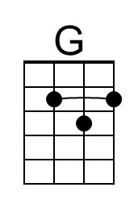 | 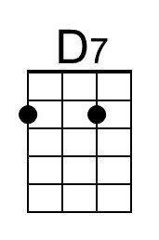 | 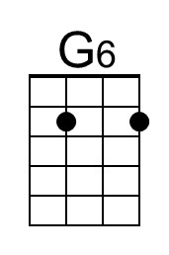 | 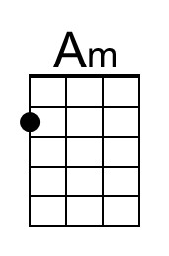 |  |  | 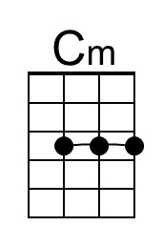 | 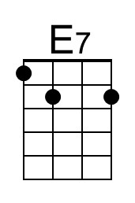
Baritone | 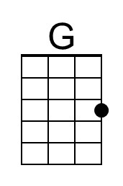 | 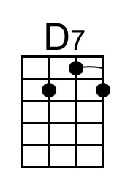 | 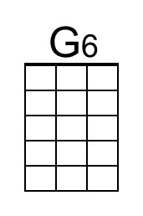 | 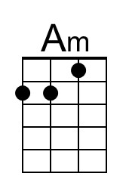 |  |  | 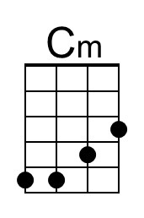 | 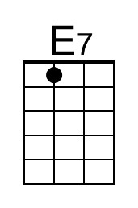

* Suggested chord strumming pattern: ||: G _ G G G _ D7 D7 :||
↓ ↑ ↓ ↑ ↓ ↑

