**Christmas Don’t Be Late (Alvin & the Chipmunks)**

C 24

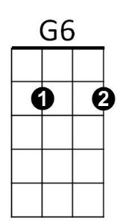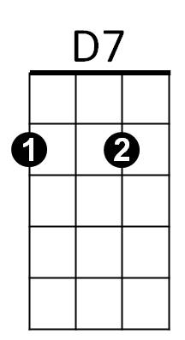**Intro: G D7 (2x)**



G

**G G6 D7**

Christmas, Christmas time is near,

**G6**

Time for toys and time for cheer.

**Am D7 Am D7**



C

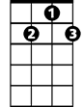

G7

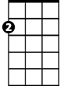

Am

We've been good, but we can't last,

**Am D7 G G6**

Hurry Christmas, hurry fast.

**G G6 G G6**

Want a plane that loops the loop,

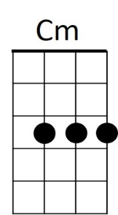**G7 C**

E7

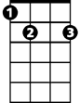

*Me, I want a Hula-Hoop.*

**C Cm G E7**

We can hardly stand the wait,

**Am D7 G D7 G D7 (Rollover)**

Please Christmas, don't be late.

**G D7 (To Outro)**

**REPEAT Song, replace line 6 with:**

**BARITONE**

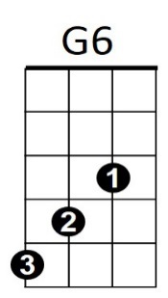**G7 C**

I *STILL want a Hula-Hoop!*



G



D7

**Outro:**

**C Cm G E7**

We can hardly stand the wait,

**Am D7 G D7 G D7 G D7 G**

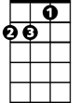

Am

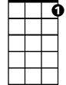

G7

C



Please Christmas, don't be late

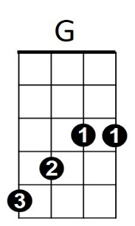

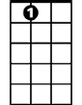

E7

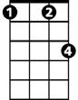

Cm