**Christmas Is the Time to Say 'I Love You' (Billy Squier)**

**Chorus:**

**C F C**

Christmas is the time to say "I love you",

**A7 Dm**

Share the joys of laughter and good cheer

**F D7 C Am**

Christmas is the time to say "I love you" –

**Dm G7 C**

And a feeling that will last all through the year

**C F C**

On the corner carolers are singing,

**A7 Dm**

There’s a touch of magic in the air

**F G C Am**

From grownup to minor no-one could be finer

**Dm G**

Times are hard but no one seems to care

**C F C**

Christmas Eve and all the world is watching,

**A7 Dm**

Santa guides his reindeer through the dark

**F G C Am**

From rooftop to chimney, from Harlem to Bimini

**Dm G C G7**

They will find a way into your heart

**(Chorus)**

**C F C**

Just outside the window snow is falling,

**A7 Dm**

But here beside the fire we share the glow

**F G C Am**

Of moonlight and brandy, sweet talk and candy

**Dm G**

Sentiments that everyone should know

**C F C**

Memories of the year that lays behind us,

**A7 Dm**

Wishes for the year that's yet to come

**F D**

And it stands to reason

**C Am**

That good friends in season

**Dm G C G7**

Make you feel that life has just begun

**(Chorus)**

**F G**

So when spirits grow lighter

**C Am**

And hopes are shining brighter

**Dm G F C**

Then you know that Christmas time is he - re.

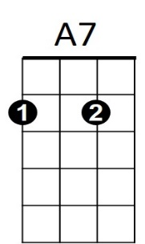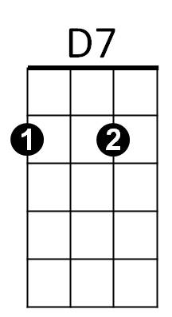



G

C

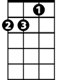

Am



D

**BARITONE**



F

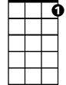

G7

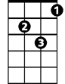

Dm

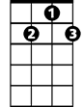

G7

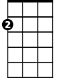

Am

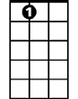

A7