
Christmas Island (Lyle Moraine, 1946)
C39 C
Christmas Island by Leon Redbone from his LP "Christmas Island" (1988)

Intro (First 2 lines of verse)  C E7 Am D7  Let's get away from sleigh bells, let’s get away from snow  Dm G7 D7 G7  Let's make a break some Christmas, dear, I know the place to go  F C A7 D7  How'd ya like to spend Christ-mas on Christmas Is-land?  G7 Dm G7 C C#dim7 G7  How'd ya like to spend the holiday a-way a-cross the sea?  F C A7 D7  How'd ya like to spend Christ-mas on Christmas Is-land?  G7 Dm G7 C G7  How'd ya like to hang a stocking on a great big coconut tree?  Bridge  F Fm C Bb A7  How'd ya like to stay up late, like the islanders do?  D7 Am D7 G7 C#dim7 G7  Wait for Santa to sail in with your presents in a ca-noe  F C A7 D7  If you ever spend Christ-mas on Christmas Is-land  G7 Dm G7 C G7  You will never stray for everyday your Christmas dreams come true.  Instrumental Verse. Repeat Bridge.  F C A7 D7  If you ever spend Christ-mas on Christmas Is-land  G7 Dm G7 C Bb A7  You will never stray, for everyday your Christmas dreams come true  D7 G7 C  On Christmas Island your dreams come true  C# C  On Christmas Is – land. |  |  |  |  |  |  | 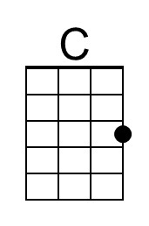 | 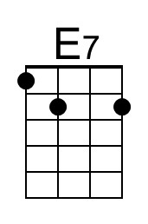
 |  |  |  |  |  |  | 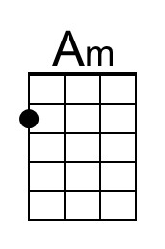 | 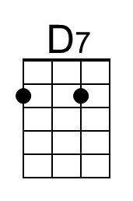
 |  |  |  |  |  |  | 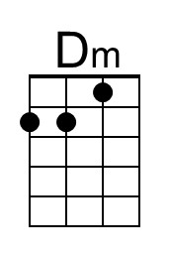 | 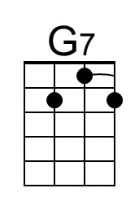
 |  |  |  |  |  |  | 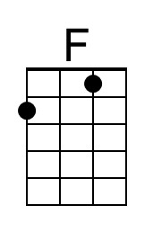 | 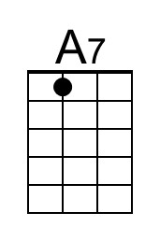
 |  |  |  |  |  |  | 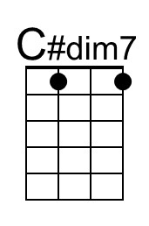 | 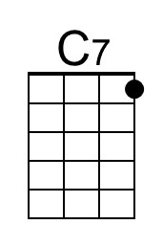
 |  |  |  |  |  |  | 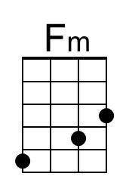 | 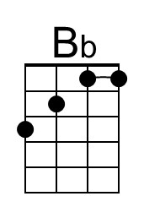
 |  |  |  |  |  |  | 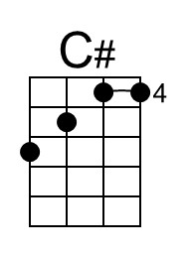
Baritone | 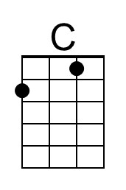 | 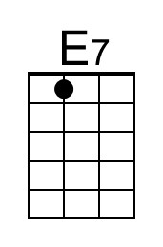 | 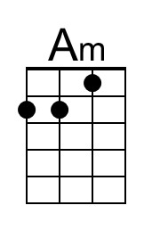 | 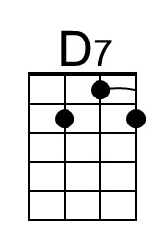 | 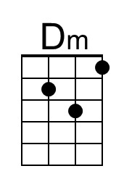 | 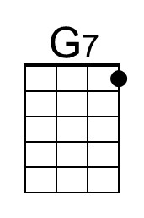
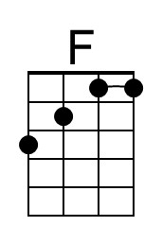 | 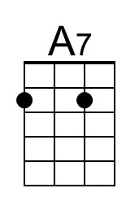 | 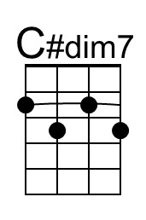 | 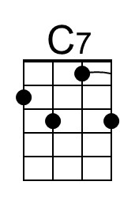 | 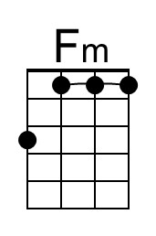 | 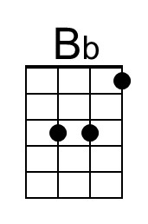 | 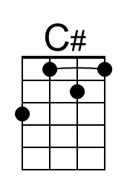

Christmas Island (Lyle Moraine, 1946)
C39 G
Christmas Island by Leon Redbone from his LP "Christmas Island" (1988)

Intro (First 2 lines of verse)  G B7 Em A7  Let's get away from sleigh bells, let’s get away from snow  Am D7 A7 D7  Let's make a break some Christmas, dear, I know the place to go  C G E7 A7  How'd ya like to spend Christ-mas on Christmas Is-land?  D7 Am D7 G Abdim7 D7  How'd ya like to spend the holiday a-way a-cross the sea?  C G E7 A7  How'd ya like to spend Christ-mas on Christmas Is-land?  D7 Am D7 G D7  How'd ya like to hang a stocking on a great big coconut tree?  Bridge  C Cm G F E7  How'd ya like to stay up late, like the islanders do?  A7 Em A7 D7 Abdim7 D7  Wait for Santa to sail in with your presents in a ca-noe  C G E7 A7  If you ever spend Christ-mas on Christmas Is-land  D7 Am D7 G D7  You will never stray for everyday your Christmas dreams come true.  Instrumental Verse. Repeat Bridge.  C G E7 A7  If you ever spend Christ-mas on Christmas Is-land  D7 Am D7 G F E7  You will never stray, for everyday your Christmas dreams come true  A7 D7 G  On Christmas Island your dreams come true  G# G  On Christmas Is – land. |  |  |  |  |  |  | 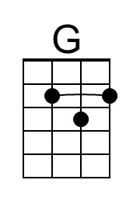 | 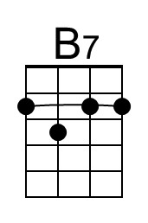
 |  |  |  |  |  |  | 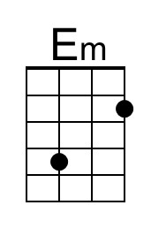
 |  |  |  |  |  |  | 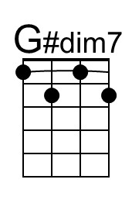
 |  |  |  |  |  |  | 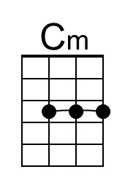
 |  |  |  |  |  |  | 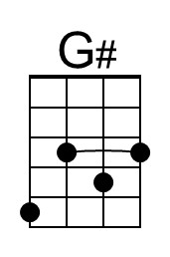
Baritone | 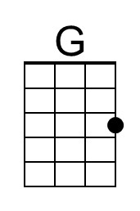 | 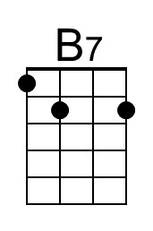 | 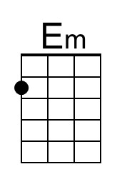
 |  | 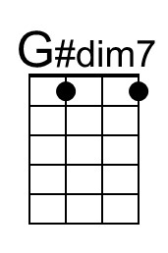 |  | 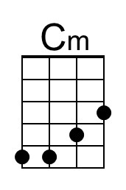 |  | 