**Christmas Time (Bryan Adams / James Vallance)**

**C G Am**

We waited all through the year,

**F C G**

For the day to ap - pear

**C E7 Am Am7 G**

When we could be to-gether - in harmony,

**C G Am**

You know the time will come,

**F C G**

Peace on earth for every - one

**C E7 Am Am7**

And we can live forever,

**Dm**

In a world where we are free,

**Dm7 G**

Let it shine for you and me

**Chorus:**

**C**

There's something about Christmas time,

**F**

Something about Christmas time

**C Am G**

That makes you wish it was Christmas every day

**C**

To see the joy in the children's eyes

**F**

The way that the old folks smile

**C G C**

Says that Christmas will never go a - way

**C G Am**

We're all as one to - night,

**F C G**

Makes no difference if you're black or white

**C E7 Am G**

‘Cause we can sing to - gether in harmony.

**C G Am**

I know it's not too late;

**F C G**

The world would be a better place

**C E7 Am Am7**

If we can keep the spirit,

**Dm**

More than one day in the year

**Dm7 G**

Send a message loud and clear

**(Chorus)**

**G C**

It's the time of year when everyone's to - gether

**G C**

We'll celebrate here on Christmas day

**Am**

When the ones you love are there

**D7 G**

You can fe - el the magic in the air,

**G7**

You know it's everywhere

**C**

There's something about Christmas time

**F A7**

Something about Christmas time **KEY CHANGE**

**(2X) D**

There's something about Christmas time

**G**

Something about Christmas time

**D Bm A**

That makes you wish it was Christmas every day

**D**

To see the joy in the children's eyes

**G**

The way that the old folks smile

**D A D**

Says that Christmas will never go a - way

**End:**

**D A D**

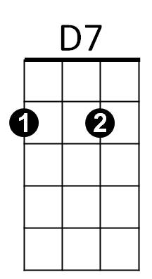Says that Christmas will never go a - way

F



C

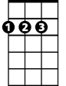

D

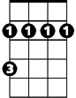

Bm

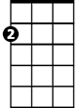

Am



G

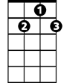

G7

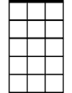

Am7

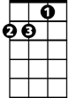

Dm

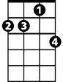

Dm7

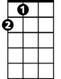

A

E7

