
Christmas Time GCEA
C94 C
(Bryan Adams & James Vallance, 1985) – Christmas Time by Bryan Adams (1985) (C @ 77)
C G Am  We waited all through the year,  F C G  For the day to ap - pear  C E7 Am Am7 G  When we could be to-gether - in harmony,  C G Am  You know the time will come,  F C G  Peace on earth for every - one  C E7 Am Am7  And we can live forever,  Dm  In a world where we are free,  Dm7 G  Let it shine for you and me  Chorus  C  There's something about Christmas time,  F  Something about Christmas time  C Am G  That makes you wish it was Christmas every day  C  To see the joy in the children's eyes  F  The way that the old folks smile  C G C  Says that Christmas will never go a - way  C G Am  We're all as one to - night,  F C G  Makes no difference if you're black or white  C E7 Am G  ‘Cause we can sing to - gether in harmony.  C G Am  I know it's not too late;  F C G  The world would be a better place |  |  |  |  | C E7 Am Am7  If we can keep the spirit,  Dm  More than one day in the year  Dm7 G  Send a message loud and clear. Chorus  G C  It's the time of year when everyone's to - gether  G C  We'll celebrate here on Christmas day  Am  When the ones you love are there  D7 G  You can fe - el the magic in the air,  G7  You know it's everywhere  C  There's something about Christmas time  F A7  Something about Christmas time Key Change  (2x)  D  There's something about Christmas time  G  Something about Christmas time  D Bm A  That makes you wish it was Christmas every day  D  To see the joy in the children's eyes  G  The way that the old folks smile  D A D  Says that Christmas will never go a - way  Outro  D A D  Says that Christmas will never go a – way.
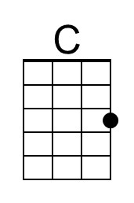 | 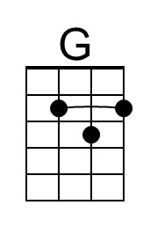 | 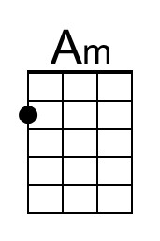 | 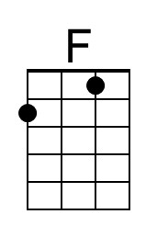 | 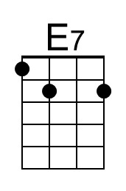 |  | 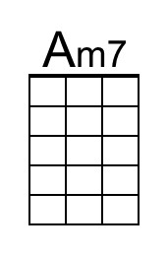 | 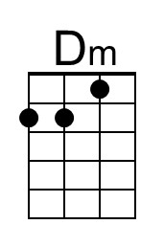
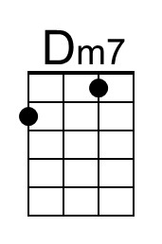 | 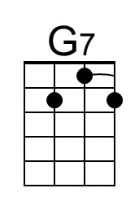 | 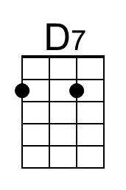 | 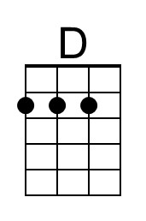 | 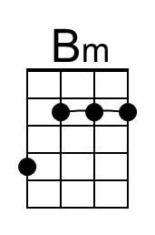 |  | 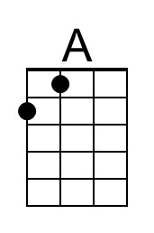

Christmas Time DGBE
C94 C
(Bryan Adams & James Vallance, 1985) – Christmas Time by Bryan Adams (1985) (C @ 77)
C G Am  We waited all through the year,  F C G  For the day to ap - pear  C E7 Am Am7 G  When we could be to-gether - in harmony,  C G Am  You know the time will come,  F C G  Peace on earth for every - one  C E7 Am Am7  And we can live forever,  Dm  In a world where we are free,  Dm7 G  Let it shine for you and me  Chorus  C  There's something about Christmas time,  F  Something about Christmas time  C Am G  That makes you wish it was Christmas every day  C  To see the joy in the children's eyes  F  The way that the old folks smile  C G C  Says that Christmas will never go a - way  C G Am  We're all as one to - night,  F C G  Makes no difference if you're black or white  C E7 Am G  ‘Cause we can sing to - gether in harmony.  C G Am  I know it's not too late;  F C G  The world would be a better place |  |  |  |  | C E7 Am Am7  If we can keep the spirit,  Dm  More than one day in the year  Dm7 G  Send a message loud and clear. Chorus  G C  It's the time of year when everyone's to - gether  G C  We'll celebrate here on Christmas day  Am  When the ones you love are there  D7 G  You can fe - el the magic in the air,  G7  You know it's everywhere  C  There's something about Christmas time  F A7  Something about Christmas time Key Change  (2x)  D  There's something about Christmas time  G  Something about Christmas time  D Bm A  That makes you wish it was Christmas every day  D  To see the joy in the children's eyes  G  The way that the old folks smile  D A D  Says that Christmas will never go a - way  Outro  D A D  Says that Christmas will never go a – way.
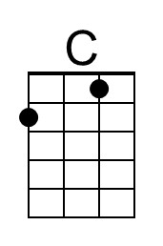 | 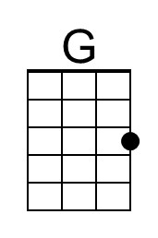 | 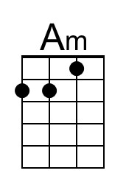 | 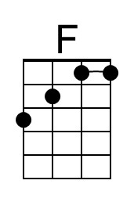 | 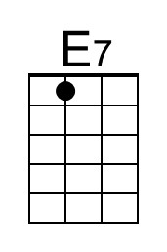 |  | 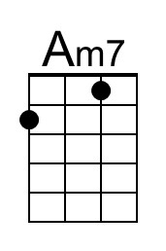 | 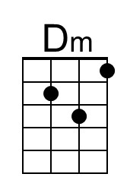
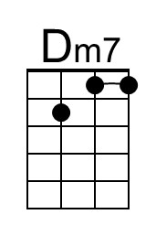 | 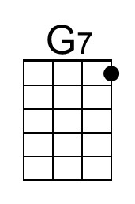 | 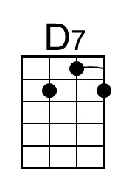 | 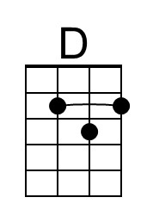 | 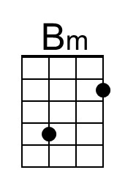 |  | 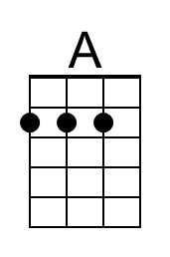

Christmas Time GCEA
C94 G
(Bryan Adams & James Vallance, 1985) – Christmas Time by Bryan Adams (1985) (C @ 77)
G D Em  We waited all through the year,  C G D  For the day to ap - pear  G B7 Em Em7 D  When we could be to-gether - in harmony,  G D Em  You know the time will come,  C G D  Peace on earth for every - one  G B7 Em Em7  And we can live forever,  Am  In a world where we are free,  Am7 D  Let it shine for you and me  Chorus  G  There's something about Christmas time,  C  Something about Christmas time  G Em D  That makes you wish it was Christmas every day  G  To see the joy in the children's eyes  C  The way that the old folks smile  G D G  Says that Christmas will never go a - way  G D Em  We're all as one to - night,  C G D  Makes no difference if you're black or white  G B7 Em D  ‘Cause we can sing to - gether in harmony.  G D Em  I know it's not too late;  C G D  The world would be a better place |  |  |  |  | G B7 Em Em7  If we can keep the spirit,  Am  More than one day in the year  Am7 D  Send a message loud and clear. Chorus  D G  It's the time of year when everyone's to - gether  D G  We'll celebrate here on Christmas day  Em  When the ones you love are there  A7 D  You can fe - el the magic in the air,  D7  You know it's everywhere  G  There's something about Christmas time  C E7  Something about Christmas time Key Change  (2x)  A  There's something about Christmas time  D  Something about Christmas time  A F#m E  That makes you wish it was Christmas every day  A  To see the joy in the children's eyes  D  The way that the old folks smile  A E A  Says that Christmas will never go a - way  Outro  A E A  Says that Christmas will never go a - way
 |  | 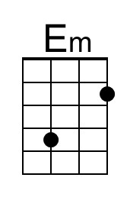 |  | 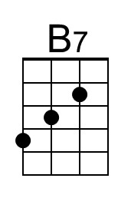 |  | 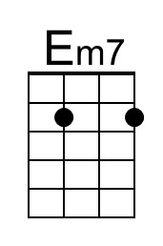
 |  | 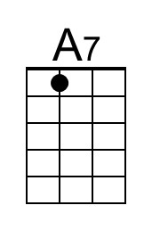 |  | 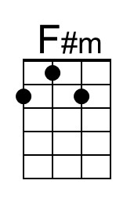 |  | 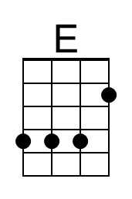

Christmas Time DGBE
C94 G
(Bryan Adams & James Vallance, 1985) – Christmas Time by Bryan Adams (1985) (C @ 77)
G D Em  We waited all through the year,  C G D  For the day to ap - pear  G B7 Em Em7 D  When we could be to-gether - in harmony,  G D Em  You know the time will come,  C G D  Peace on earth for every - one  G B7 Em Em7  And we can live forever,  Am  In a world where we are free,  Am7 D  Let it shine for you and me  Chorus  G  There's something about Christmas time,  C  Something about Christmas time  G Em D  That makes you wish it was Christmas every day  G  To see the joy in the children's eyes  C  The way that the old folks smile  G D G  Says that Christmas will never go a - way  G D Em  We're all as one to - night,  C G D  Makes no difference if you're black or white  G B7 Em D  ‘Cause we can sing to - gether in harmony.  G D Em  I know it's not too late;  C G D  The world would be a better place |  |  |  |  | G B7 Em Em7  If we can keep the spirit,  Am  More than one day in the year  Am7 D  Send a message loud and clear. Chorus  D G  It's the time of year when everyone's to - gether  D G  We'll celebrate here on Christmas day  Em  When the ones you love are there  A7 D  You can fe - el the magic in the air,  D7  You know it's everywhere  G  There's something about Christmas time  C E7  Something about Christmas time Key Change  (2x)  A  There's something about Christmas time  D  Something about Christmas time  A F#m E  That makes you wish it was Christmas every day  A  To see the joy in the children's eyes  D  The way that the old folks smile  A E A  Says that Christmas will never go a - way  Outro  A E A  Says that Christmas will never go a - way
 |  | 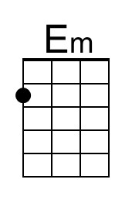 |  | 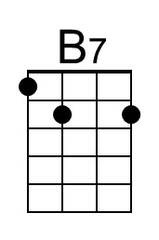 |  | 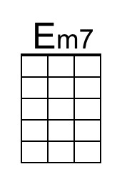
 |  | 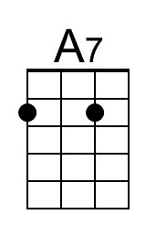 |  | 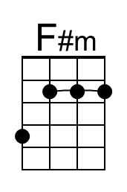 |  | 