Christmas Times a-Comin’ (Benjamin “Tex” Logan, 1951) (C)
(Charles de Lint version)

Intro: Strum in on C  C G7  Christmas time's a-comin', Christmas time's a-comin'  C G7 C  Christmas time's a-comin' and I know I'm goin' home  C G7  Holly's in the window home where the wind blows  C G7 C  Can't walk for runnin,' Christmas time's a-comin'  Chorus  C F  Can't you hear them bells ringin', ringin' joy to all, hear them singin'  C G7 C  When it's snowin', I'll be goin' back to my country home.  C G7  Christmas time's a-comin', Christmas time's a-comin',  C G7 C  Christmas time's a-comin', and I know I'm goin' home.  Instrumental:  C G7  Christmas time's a-comin', Christmas time's a-comin',  C G7 C  Christmas time's a-comin', and I know I'm goin' home.  C G7  White candle's burnin' my old heart's a-yearnin'  C G7 C  For the folks at home when Christmas time's a-comin'. Chorus & Instrumental  C G7  Snow flake's a-fallin', my old home's a-callin',  C G7 C  Tall pine's a-hummin', Christmas time's a-comin'. Chorus  C F  Can't you hear them bells ringin', ringin' joy to all, hear them singin',  C G7 C  When it's snowin', I'll be goin' back to my country home.  C G7  Christmas time's a-comin', Christmas time's a-comin',  C G7 C↓  Christmas time's a-comin', and I know I'm goin' home. | 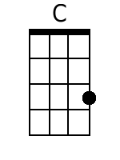
 | 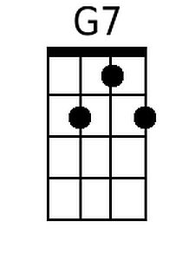
 | 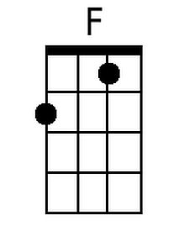
 | Baritone
 | 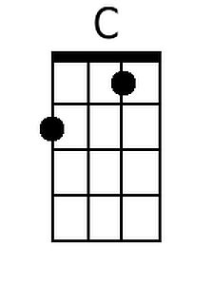
 | 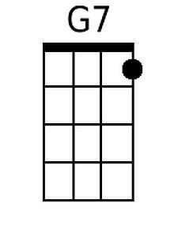
 | 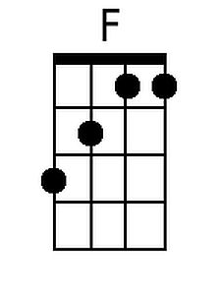

Christmas Times a-Comin’ (Benjamin “Tex” Logan, 1951) (G)
(Charles de Lint version)

Intro: Strum in on G  G D7  Christmas time's a-comin', Christmas time's a-comin'  G D7 G  Christmas time's a-comin' and I know I'm goin' home  G D7  Holly's in the window home where the wind blows  G D7 G  Can't walk for runnin,' Christmas time's a-comin'  Chorus  G C  Can't you hear them bells ringin', ringin' joy to all, hear them singin'  G D7 G  When it's snowin', I'll be goin' back to my country home.  G D7  Christmas time's a-comin', Christmas time's a-comin',  G D7 G  Christmas time's a-comin', and I know I'm goin' home.  Instrumental:  G D7  Christmas time's a-comin', Christmas time's a-comin',  G D7 G  Christmas time's a-comin', and I know I'm goin' home.  G D7  White candle's burnin' my old heart's a-yearnin'  G D7 G  For the folks at home when Christmas time's a-comin'. Chorus & Instrumental  G D7  Snow flake's a-fallin', my old home's a-callin',  G D7 G  Tall pine's a-hummin', Christmas time's a-comin'. Chorus  G C  Can't you hear them bells ringin', ringin' joy to all, hear them singin',  G D7 G  When it's snowin', I'll be goin' back to my country home.  G D7  Christmas time's a-comin', Christmas time's a-comin',  C G7 C↓  Christmas time's a-comin', and I know I'm goin' home. | 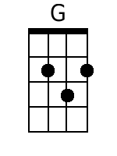
 | 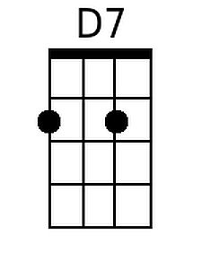
 | Baritone
 | 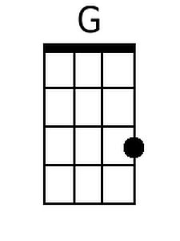
 | 