**Christmas in Dixie (Jeff Cook, Teddy Gentry, Mark Herndon & Randy Owen)**

C36

**Intro: Chords for chorus**

**C Dm G7**

By now in New York City,

**Cmaj7 C**

There’s snow on the ground

**Dm G7**

And out in California,

**Cmaj7 C**

The sunshine’s falling down

**C7 F G7**

And maybe in Memphis,

**C Am**

Graceland’s in lights,

**Dm G7**

And in Atlanta, Georgia,

**C**

There’s peace on earth tonight

**Chorus:**

**C↓ C↓ C↓ F G7**

Christ-mas in Dixie

**C Am**

It’s snowing in the pines

**Dm G7**

Merry Christmas from Dixie

**C**

To everyone tonight



C

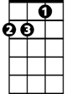

Dm

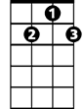

G7

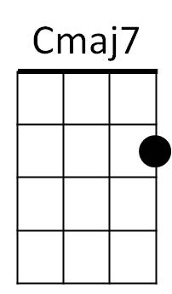

F

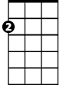

Am

**C Dm G7**

It’s windy in Chicago

**Cmaj7 C**

The kids are out of school

**Dm G7**

There’s magic in Motown

**Cmaj7 C**

The city’s on the move

**C7 F G7**

In Jackson, Mississippi,

**C Am**

To Charlotte, Caroline

**Dm G7**

And all across the nation

**C**

It’s a peaceful Christmas time

**Repeat from Chorus**

**(Chorus)**

**Dm**

And from Huntsville, Alabama …

**G7 C**

Merry Christmas tonight.

**BARITONE**

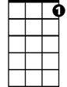

G7

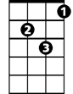

Dm

C



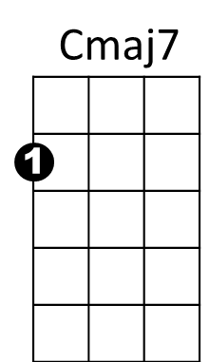



Am



F