**Christmas in Japan (Paul Anka)**

**G Em Am D**

Snowflakes falling down on every little town

**G Bm G**

Em

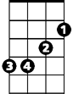

G

A blanket of stars above

**Em Am D**

The moon up above sets the mood for love

**G Em Am D G F7 Am D7**

It’s Christmas, its Christmas, Christmas in Japan

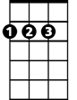

D

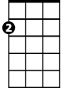

Am

**G Em Am D**

People often go to good old Tokyo

**G Bm G**

And walk up and down old Ginza

**Em Am D**

Church bells are ringing, children are singing

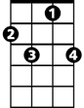

F7

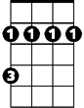

Bm

**G Em Am D G C G**

It’s Christmas, its Christmas, Christmas in Japan

**D G**

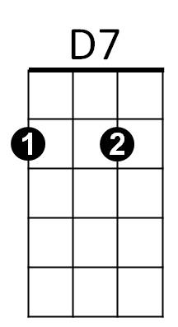Don’t pass it by, why don’t you try

**A7 D**

To - come - here next year - And we will

**G Em Am D**

Go, yes we’ll go to good old Tokyo

**G Bm G**

And walk up and down old Ginza

**Em Am D**

Bells will be ringing, we will be singing

**G Em Am D G C G D**

It’s Christmas, its Christmas, Christmas in Japan

**G Em Am D G C D (PAUSE)**

It’s Christmas, its Christmas, Christmas in Japan

**TACET G Em Am D G**

Christmas, omede-to - to - you

Bm

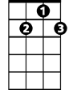

D7

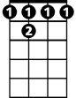

F 7

**BARITONE**



D

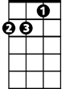

Am



Em



G