**Christmas in the Trenches (John McCutcheon)**

**G Em C Am**

My name is Francis Toliver, I come from Liverpool.

**D7 C G**

Two years ago the war was waiting for me after school.

**G Em C Am**

To Belgium and to Flanders, Germany to here.

**D7 G**

I fought for King and country I love dear.

**D7 C G**

‘Twas Christmas in the trenches, where the frost so bitter hung.

**Em**

The frozen fields of France were still,

**C D7**

No Christmas song was sung.

**G Em C Am**

Our families back in England were toasting us that day,

**D7 G**

Their brave and glorious lads so fa r away.

**G Em C Am**

I was lying with my mess mates on the cold and rocky ground.

**D7 C G**

When across the lines of battle came a most peculiar sound.

**G Em C Am**

Says I, "now listen up me boys." Each soldier strained to hear

**D7 G**

As one young German voice sang out so clear.

**D7 C G**

"He's singing bloody well y'know," my partner says to me.

**Em C D7**

Soon one by one each German voice joined in in harmony.

**G Em C Am**

The cannons rested silent, and the gas clouds rolled no more.

**D7 G**

As Christmas brought us respite from the war.

**G Em C Am**

As soon as they were finished, and a reverent pause was spent,

**D7 C G**

"God Rest Ye Merry Gentlemen" struck up some lads from Kent.

**G Em C Am**

Oh the next they sang was "Stille Nacht", 'tis Silent Night says I.

**D7 G**

And in two tongues one song filled up that sky.

**D7 C G**



G

"There's someone coming towards us", the front line sentry cried.

**Em C D7**

All sights were fixed on one lone figure trudging from their side.

**G Em C Am**

His truce flag like a Christmas star shone on that plain so bright

**D7 G**

As he bravely strolled unarmed into the night.

**G Em C Am**

Then one by one on either side walked into No-Man's Land.

**D7 C G**

With neither gun nor bayonet we met there hand to hand.

**G Em C Am**

We shared some secret brandy and we wished each other well.

**D7 G**



G

**BARITONE**

C

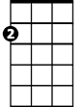

Em

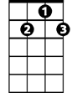

D7

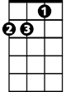

Am

And in a flare-lit soccer game we gave 'em hell.

**D7 C G**

We traded chocolates, cigarettes and photographs from home.

**Em C D7**

These sons and fathers far away from families of their own.

**G Em C Am**

Young Sanders played the squeezebox and they had a violin.

**D7 G**

This curious and unlikely band of men.

**G Em C Am**

Soon daylight stole upon us and France was France once more.

**D7 C G**

With sad farewells we each began to settle back to war.

**G Em C**

But the question haunted every heart that lived that wondrous

**Am**

night.

**D7 G**

"Whose family have I fixed within my sights?"

**D7 C G**

’Twas Christmas in the trenches, where the frost so bitter hung.

**Em**

The frozen fields of France were warmed

**C D7**

As songs of peace were sung.

**G Em C Am**

For the walls they kept between us to exact the work of war

**D7 G**

Had been crumbled and were gone forever more.

**G Em C Am**

My name is Francis Toliver, in Liverpool I dwell.

**D7**

Each Christmas comes since World War I,

**C G**

I've learned its lessons well.

**G Em C**

For the ones who call the shots won't be among the dead and

**Am**

lame,

**D7 G**

And on each end of the rifle we're the same.

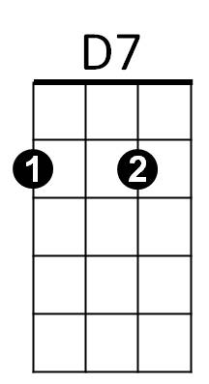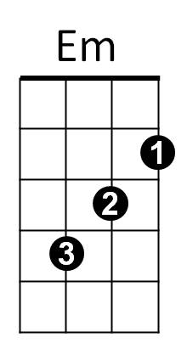



Am



C