**Chug-a-lug (Roger Miller)**

**Intro: G C D7 C (3x) G**

**CHORUS:**

**TACET**

Chug-a-lug Chug-a-lug

**G D7**

Make you wanna holler hid-e-ho

**G**

Burns your tummy don't you know

**D7 G**

Chug-a-lug Chug-a-lug

**TACET G**

Grape wine in a mason jar

**D7**

Homemade and brought to school

**G**

By a friend of mine after class

**D7**

Me and him and this other fool decide

**G**

That we'll drink up what’s left

**D7**



G

Chug-a-lug so I helped ourselves

**G**

First time for everything

**TACET**

Mmmm my ears still ring

**(CHORUS)**

**G**

4-H and FFA

**D7**

On a field trip to the farm

**BARITONE**

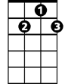

D7

**G**

C



G

Me and a friend sneak off behind

**D7**

This big old barn

**G**

Where we uncovered this covered up moonshine still

**D7**

How we thought we’d drink our fill

**G**

I swallered it with a smile

**TACET**

Ughhh I run ten miles

**(CHORUS)**

**G**

Jukebox and a sawdust floor

**D7**

Something like I ain't never seen

**G**

Heck I'm just going on fifteen

**D7**

But with the help of my fan-egleing uncle

**G D7**

I get snuck in for my first taste of sin

**G**

I said let me have a big old sip

**TACET**

I done a double back flip

**(CHORUS)**

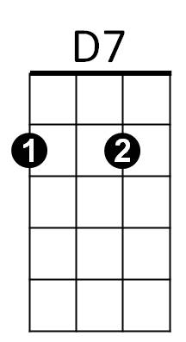



C