City of New Orleans (Steve Goodman) (C)

C G7 C
Riding on the city of New Orleans
Am F C
Illinois Central Monday morning rail
G7 C
Fifteen cars and fifteen restless riders
Am G7 C
Three conductors and twenty five sacks of mail
Am
All a-long the southbound Odyssey
Em
The train pulls out of Kankakee
G7 D7
And rolls along past houses farms and fields
Am
Passing trains that have no name
Em
And freight yards full of old black men
G7 C C7
And the graveyards of the rusted auto-mobiles

Chorus:
F G7 C
Good morning America how are you
Am F C
Say don't you know me I'm your native son
G7 C G7 Am
I'm the train they call the City of New Orleans
Bb G7 C
I'll be gone five hundred miles when the day is done.

G7 C
Dealing card game with the old men in the club car
Am F C
Penny a point ain't no one keeping score
G7 C
Pass the paper bag that holds the bottle
Am G7 C
Feel the wheels rumbling 'neath the floor
Am
And the sons of Pullman porters
Em
And the sons of engineers
G7 D7
Ride their fathers' magic carpet made of steel
Am
Mothers with their babes a sleep
Em
Rocking to the gentle beat
G7 C C7
And the rhythm of the rails is all they feel. Chorus

G7 C
Nighttime on the City of New Orleans
Am F C
Changing cars in Memphis Tennessee
G7 C
Halfway home and we'll be there by morning
Am
Through the Mississippi darkness
G7 C
Rolling down to the sea
Am
And all the towns and people seem
Em
To fade into a bad dream
G7 D7
And the steel rail still ain't heard the news
Am
The conductor sings his songs again
Em
The passengers will please refrain
G7 C C7
This train got the disappearing railroad blues.
(Chorus 2X) ( GOOD NIGHT )

GCEA | 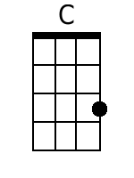 | 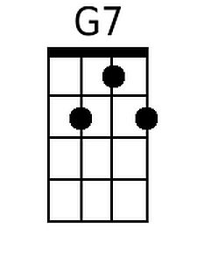 | 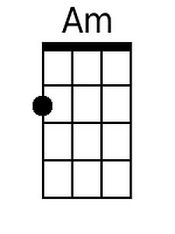 | 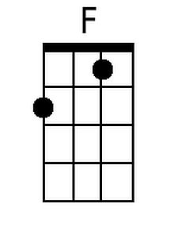 | 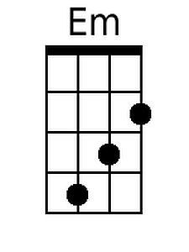 | 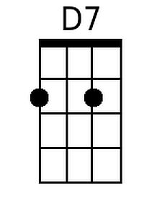 | 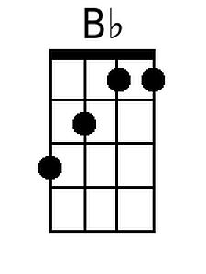
DGBE | 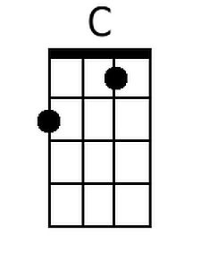 | 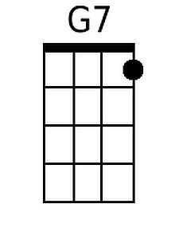 | 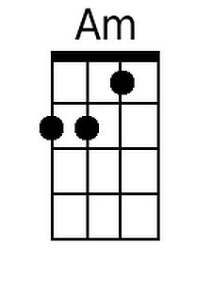 | 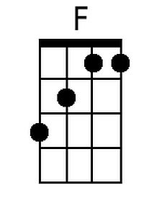 | 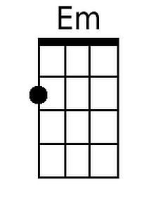 | 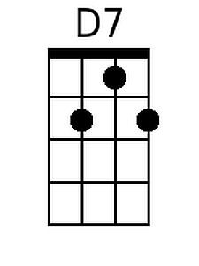 | 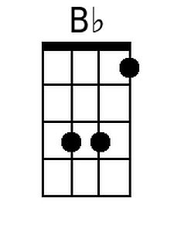

City of New Orleans (Steve Goodman) (G)

G D7 G
Riding on the city of New Orleans
Em C G
Illinois Central Monday morning rail
D7 G
Fifteen cars and fifteen restless riders
Em D7 G
Three conductors and twenty five sacks of mail
Em
All a-long the southbound Odyssey
Bm
The train pulls out of Kankakee
D7 A7
And rolls along past houses farms and fields
Em
Passing trains that have no name
Bm
And freight yards full of old black men
D7 G G7
And the graveyards of the rusted auto-mobiles

Chorus:
C D7 G
Good morning America how are you
Em C G
Say don't you know me I'm your native son
D7 G D7 Em
I'm the train they call the City of New Orleans
F D7 G
I'll be gone five hundred miles when the day is done

D7 G
Dealing card game with the old men in the club car
Em C G
Penny a point ain't no one keeping score
D7 G
Pass the paper bag that holds the bottle
Em D7 G
Feel the wheels rumbling 'neath the floor
Em
And the sons of Pullman porters
Bm
And the sons of engineers
D7 A7
Ride their fathers' magic carpet made of steel
Em
Mothers with their babes a sleep
Bm
Rocking to the gentle beat
D7 G G7
And the rhythm of the rails is all they feel. Chorus

D7 G
Nighttime on the City of New Orleans
Em C G
Changing cars in Memphis Tennessee
D7 G
Halfway home and we'll be there by morning
Em
Through the Mississippi darkness
D7 G
Rolling down to the sea
Em
And all the towns and people seem
Bm
To fade into a bad dream
D7 A7
And the steel rail still ain't heard the news
Em
The conductor sings his songs again
Bm
The passengers will please refrain
D7 G G7
This train got the disappearing railroad blues.
(Chorus 2x) ( GOOD NIGHT )

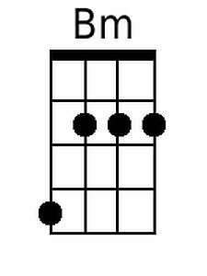  GCEA | 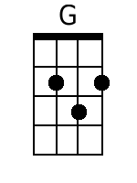 |  |  |  |  | 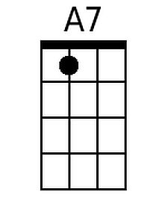
DGBE | 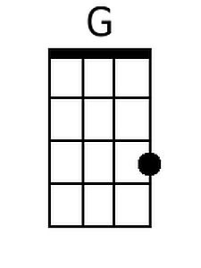 |  |  |  | 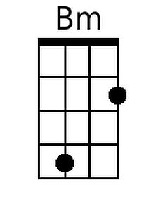 | 