
City of New Orleans (Steve Goodman, ca. 1971) (C)

C G7 C  Riding on the city of New Orleans,  Am F C  Illinois Central Monday morning rail.  G7 C  Fifteen cars and fifteen restless riders,  Am G7 C  Three con-ductors and twenty five sacks of mail.  Am  All a-long the southbound Odyssey,  Em  The train pulls out of Kankakee,  G7 D7  And rolls along past houses farms and fields.  Am  Passing towns that have no name,  Em  And freight yards full of old black men,  G7 C C7  And the graveyards of the rusted auto-mobiles.  Chorus  F G7 C  Good morning America how are you?  Am F C G7  Say don't you know me I'm your native son?  C G7 Am  I'm the train they call the City of New Orleans.  Bb G7 C  I'll be gone five hundred miles when the day is done.  G7 C  Dealing card game with the old men in the club car.  Am F C  Penny a point ain't no one keeping score.  G7 C  Pass the paper bag that holds the bottle,  Am G7 C  Feel the wheels rumbling 'neath the floor. |  |  |  |  | Am  And the sons of Pullman porters  Em  And the sons of engineers,  G7 D7  Ride their fathers' magic carpet made of steel.  Am  Mothers with their babes a sleep,  Em  Rocking to the gentle beat,  G7 C C7  And the rhythm of the rails is all they feel. Chorus  G7 C  Nighttime on the City of New Orleans,  Am F C  Changing cars in Memphis, Tennessee.  G7 C  Halfway home and we'll be there by morning,  Am  Through the Mississippi darkness,  G7 C  Rolling down to the sea.  Am  And all the towns and people seem  Em  To fade into a bad dream,  G7 D7  And the steel rail still ain't heard the news.  Am  The conductor sings his songs again,  Em  The passengers will please refrain.  G7 C C7  This train got the disappearing railroad blues.  (Chorus) (GOOD NIGHT) (Repeat last line to end)
 | GCEA | 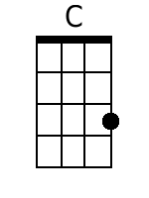 | 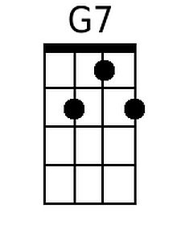 | 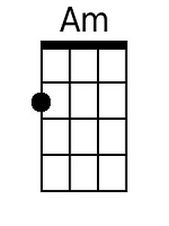 |  | 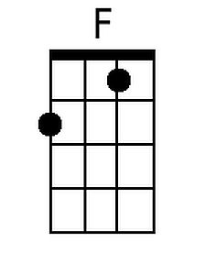 | 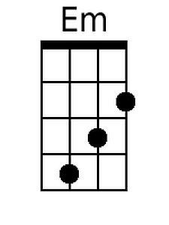 | 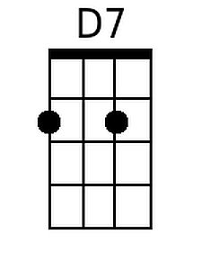 | 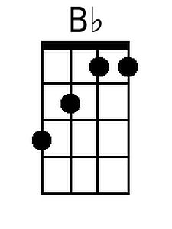
 | DGBE | 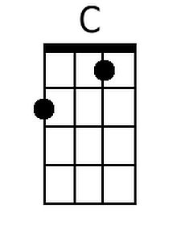 | 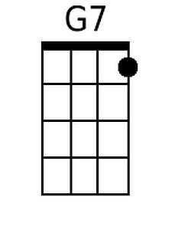 | 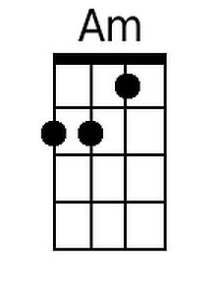 |  | 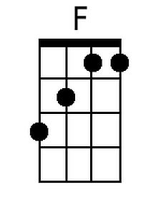 | 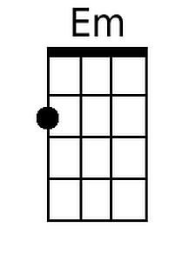 | 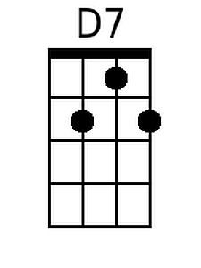 | 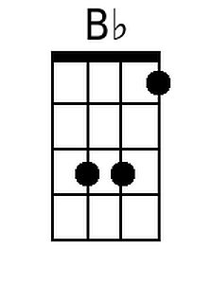

City of New Orleans (Steve Goodman, ca. 1971) (G)

G D7 G  Riding on the city of New Orleans,  Em C G  Illinois Central Monday morning rail.  D7 G  Fifteen cars and fifteen restless riders,  Em D7 G  Three con-ductors and twenty five sacks of mail.  Em  All a-long the southbound Odyssey,  Bm  The train pulls out of Kankakee,  D7 A7  And rolls along past houses farms and fields.  Em  Passing towns that have no name,  Bm  And freight yards full of old black men,  D7 G G7  And the graveyards of the rusted auto-mobiles.  Chorus:  C D7 G  Good morning America how are you?  Em C G D7  Say don't you know me I'm your native son?  G D7 Em  I'm the train they call the City of New Orleans.  F D7 G  I'll be gone five hundred miles when the day is done.  D7 G  Dealing card game with the old men in the club car,  Em C G  Penny a point ain't no one keeping score.  D7 G  Pass the paper bag that holds the bottle,  Em D7 G  Feel the wheels rumbling 'neath the floor. |  |  |  |  | Em  And the sons of Pullman porters  Bm  And the sons of engineers,  D7 A7  Ride their fathers' magic carpet made of steel.  Em  Mothers with their babes a sleep,  Bm  Rocking to the gentle beat,  D7 G G7  And the rhythm of the rails is all they feel. Chorus  D7 G  Nighttime on the City of New Orleans,  Em C G  Changing cars in Memphis Tennessee.  D7 G  Halfway home and we'll be there by morning,  Em  Through the Mississippi darkness  D7 G  Rolling down to the sea.  Em  And all the towns and people seem  Bm  To fade into a bad dream,  D7 A7  And the steel rail still ain't heard the news.  Em  The conductor sings his songs again,  Bm  The passengers will please refrain.  D7 G G7  This train got the disappearing railroad blues.  (Chorus) (GOOD NIGHT) (Repeat last line to end)
 | 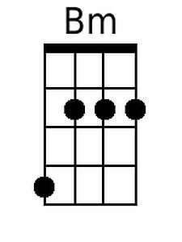  GCEA | 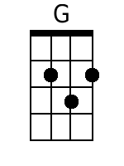 |  |  |  |  |  | 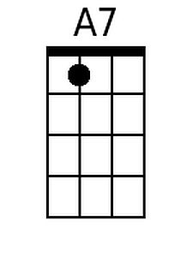
 | DGBE | 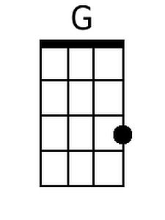 |  |  |  |  | 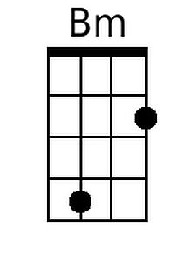 | 