Cold as Ice (Lou Gramm / Mick Jones)

Intro: Am F  Am  You're as cold as ice  F Am F  You're willing to sacrifice our love  Am  You never take advice  F Dm  Someday you'll pay the price, I know  Chorus:  C  I've seen it before -  Cmaj7  It happens all the time  Dm  Closing the door  F  You leave the world behind  C  You're digging for gold  Cmaj7  Yet throwing away  Dm  A fortune in feelings  E7  But someday you'll pay |  |  | Am F  Am  You're as cold as ice  F Am F  You're willing to sacrifice our love  Am  You want paradise  F Dm  But someday you'll pay the price, I know  Chorus.  F Am / F Dm C E  Bridge:  Am E7 Ddim  Cold - as - ice -  You know that you are  Am E7 Ddim  Cold - as - ice -  As cold as ice to me  Am E7 Ddim  Cold - as - ice -  (Fade out) end with Am  Am F |  |  | 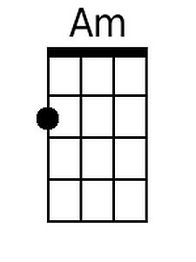  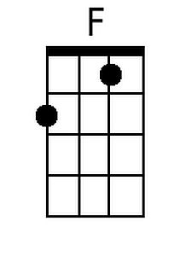  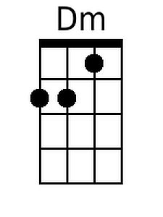  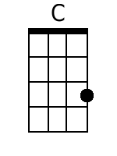  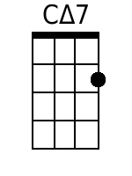  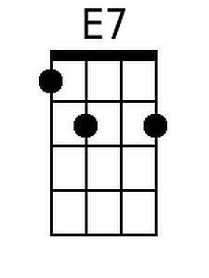  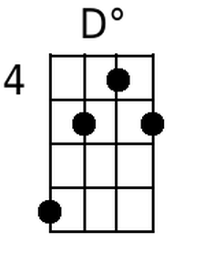
Bari
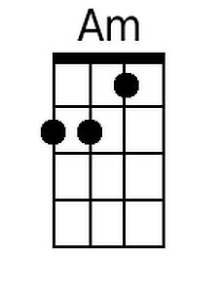 | 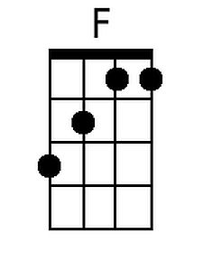 | 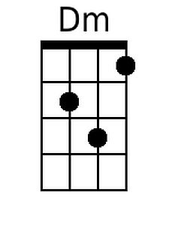 | 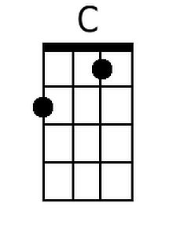
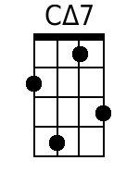 | 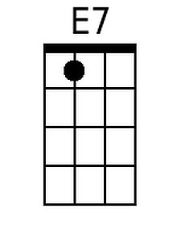 | 