**Cold as Ice (Lou Gramm / Mick Jones)**

**Intro: Em C**

**Em**

You're as cold as ice

**C Em C**

You're willing to sacrifice our love

**Em**

You never take advice

**C Am**

Someday you'll pay the price, I know

**Chorus:**

**G Gmaj7**

I've seen it before - It happens all the time

**Am**

Closing the door

**C**

You leave the world behind

**G**

You're digging for gold

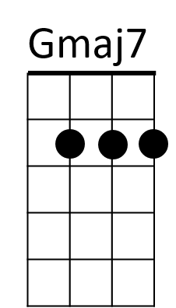 **Gmaj7**

Yet throwing away

**Am**

A fortune in feelings

**B7**

But som eday you'll pay

**Em C**

**Em**

C

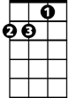

Am



G

**BARITONE**

You're as cold as ice

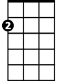

Em

**C Em C**

You're willing to sacrifice our love

**Em**

You want paradise

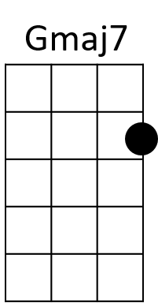**C Am**

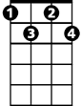

Adim

B7

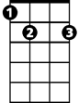

But someday you'll pay the price, I know

**(Chorus)**

**C Em / C Am G B**

**Bridge:**

**Em B7 Adim**

Cold – as - ice - You know that you are

**Em B7 Adim**

Cold – as - ice - As cold as ice to me

**Em B7 Adim**

Cold – as - ice -

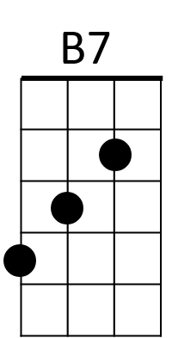**Em C (Fade out) end with Em**

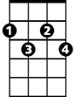

Adim



G



Am

Em

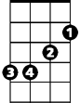

C