**Colours (Donovan) Key C**

**C**

Yellow is the colour of my true love's hair

**F C**

In the morning, when we rise

**F C**

In the morning, when we rise

**G7 F**

That's the time, that's the time

**C**

I love the best

**C**

Blue's the colour of the sky-y

**F C**

In the morning, when we rise

**F C**

In the morning, when we rise

**G7 F**

That's the time, that's the time

**C**

I love the best

**C**

Green's the colour of the sparklin' corn

**F C**

In the morning, when we rise

**F C**

In the morning, when we rise

**G7 F**

That's the time, that's the time

**C**

I love the best

**C**

Mellow is the feeling that I get

**F C**

When I see her, m-hmm

**F C**

When I see her, oh yeah

**G7 F**

That's the time, that's the time

**C**

I love the best

**C**

Freedom is a word I rarely use

**F C**

Without thinking, oh yeah

**F C**

Without thinking, m-hmm

**G7 F**

Of the time, of the time

**C**

When I've been loved

F



C

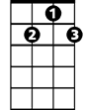

G7

**BARITONE**

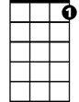

G7



F

C



**Colours (Donovan) Key G**

**G**

Yellow is the colour of my true love's hair

**C G**

In the morning, when we rise

**C G**

In the morning, when we rise

**D7 C**

That's the time, that's the time

**G**

I love the best

**G**

Blue's the colour of the sky-y

**C G**

In the morning, when we rise

**C G**

In the morning, when we rise

**D7 C**

That's the time, that's the time

**G**

I love the best

**G**

Green's the colour of the sparklin' corn

**C G**

In the morning, when we rise

**C G**

In the morning, when we rise

**D7 C**

That's the time, that's the time

**G**

I love the best

**G**

Mellow is the feeling that I get

**C G**

When I see her, m-hmm

**C G**

When I see her, oh yeah

**D7 C**

That's the time, that's the time

**G**

I love the best

**G**

Freedom is a word I rarely use

**C G**

Without thinking, oh yeah

**C G**

Without thinking, m-hmm

**D7 C**

Of the time, of the time

**G**

When I've been loved

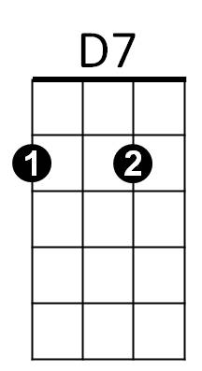



C



G

**BARITONE**



D7



G

C



**Colours (Donovan) (Nashville Notation)**

**1**

Yellow is the colour of my true love's hair

**4 1**

In the morning, when we rise

**4 1**

In the morning, when we rise

**5(7) 4**

That's the time, that's the time

**1**

I love the best

**1**

Blue's the colour of the sky-y

**4 1**

In the morning, when we rise

**4 1**

In the morning, when we rise

**5(7) 4**

That's the time, that's the time

**1**

I love the best

**1**

Green's the colour of the sparklin' corn

**4 1**

In the morning, when we rise

**4 1**

In the morning, when we rise

**5(7) 4**

That's the time, that's the time

**1**

I love the best

**1**

Mellow is the feeling that I get

**4 1**

When I see her, m-hmm

**4 1**

When I see her, oh yeah

**5(7) 4**

That's the time, that's the time

**1**

I love the best

**1**

Freedom is a word I rarely use

**4 1**

Without thinking, oh yeah

**4 1**

Without thinking, m-hmm

**5(7) 4**

Of the time, of the time

**1**

When I've been loved

|  |  |  |
| --- | --- | --- |
| 1 | 4(7) | 5 |
| A | D7 | E |
| Bb | Eb | F |
| B | E | F# |
| C | F | G |
| D | G | A |
| E | A | B |
| F | Bb | C |
| G | C | D |