Columbia, the Gem of the Ocean (Thomas A'Becket, Sr. / David Shaw)

C G C
O Columbia, the gem of the ocean,
F Dm C G
The home of the brave and the fre - e
D D7 G
The shrine of each patriot's devotion,
C D G
A world offers homage to thee.
G7 C
Thy mandates make heroes assemble,
F G
When Liberty's form stands in view
C C7 F
Thy banners make tyranny tremble,
Dm G C
When borne by the red, white, and blue!
G G7 C
When borne by the red, white, and blue!
G G7 C
When borne by the red , white, and blue!
C7 F
Thy banners make tyranny tremble,
Dm G C

When borne by the red, white, and blue!
C

C G C
When war winged it’s wide desolations,
F Dm C G
And threatened the land to deform

D D7 G
G
The ark then of freedom's foundation,
C D G
Columbia, rode safe through the storm
G7 C
With t he garlands of vict'ry about her,
F G
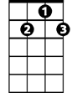
When so proudly she bore her brave crew
D7
C C7 F
With her flag proudly floating before her,
Dm G C
The boast of the red, white, and blue!
G G7 C
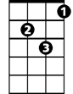
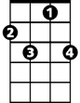
The boast of the red, white, and blue!
Dm
C7
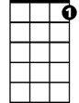
G G7 C
C7
The boast of the red, white, and blue!
C7 F
With her flag proudly floating before her,
Dm G C
The boast of the red, white, and blue!

C G C
The Star-Spangled Banner bring hither,
F Dm C G
O'er Columbia's true sons let it wave
D D7 G
May the wreaths they have won never wither,
C D G
Nor its stars cease to shine on the brave
G7 C
May the service united ne'er sever,
F G
But hold to their colors so true
C C7 F
The Army and Navy forever,
Dm G C
Three cheers for the red, white, and blue!
G G7 C
Three cheers for the red, white, and blue!
G G7 C
Three cheers for the red, white, and blue!
C7 F
The Army and Navy forever,,
Dm G C


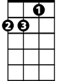
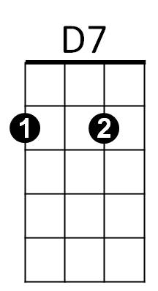
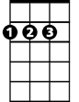
Three cheers for the red, white, and blue!
BARITONE
G7
D
G
F
C
F
Dm
G7
D

