**Columbia, the Gem of the Ocean (Thomas A'Becket, Sr. / David Shaw)**

**C G C**

O Columbia, the gem of the ocean,

**F Dm C G**

The home of the brave and the fre - e

**D D7 G**

The shrine of each patriot's devotion,

**C D G**

A world offers homage to thee.

**G7 C**

Thy mandates make heroes assemble,

**F G**

When Liberty's form stands in view

**C C7 F**

Thy banners make tyranny tremble,

**Dm G C**

When borne by the red, white, and blue!

**G G7 C**

When borne by the red, white, and blue!

**G G7 C**

When borne by the red , white, and blue!

**C7 F**

Thy banners make tyranny tremble,

**Dm G C**

When borne by the red, white, and blue!



C

**C G C**

When war winged it’s wide desolations,

**F Dm C G**

And threatened the land to deform

**D D7 G**



G

The ark then of freedom's foundation,

**C D G**

Columbia, rode safe through the storm

**G7 C**

With t he garlands of vict'ry about her,

**F G**

When so proudly she bore her brave crew

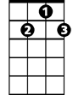

D7

**C C7 F**

With her flag proudly floating before her,

**Dm G C**

The boast of the red, white, and blue!

**G G7 C**

The boast of the red, white, and blue!

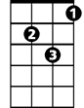

Dm

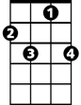

C7

**G G7 C**

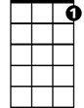

C7

The boast of the red, white, and blue!

**C7 F**

With her flag proudly floating before her,

**Dm G C**

The boast of the red, white, and blue!

**C G C**

The Star-Spangled Banner bring hither,

**F Dm C G**

O'er Columbia's true sons let it wave

**D D7 G**

May the wreaths they have won never wither,

**C D G**

Nor its stars cease to shine on the brave

**G7 C**

May the service united ne'er sever,

**F G**

But hold to their colors so true

**C C7 F**

The Army and Navy forever,

**Dm G C**

Three cheers for the red, white, and blue!

**G G7 C**

Three cheers for the red, white, and blue!

**G G7 C**

Three cheers for the red, white, and blue!

**C7 F**

The Army and Navy forever,,

**Dm G C**

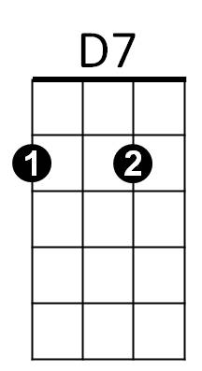Three cheers for the red, white, and blue!

**BARITONE**



G7



D



G



F

C



F

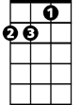

Dm



G7

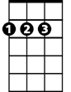

D