**Come Saturday Morning (Dory Previn / Fred Karlin)**

**(Theme song for “The Sterile Cuckoo” 1970)**

F



C

**C F Fm**

Come Saturday morning,

**C Bb**

I'm goin' away with my friend.

**F Bb Asus4 A Asus4 A**

We'll Saturday spend till the end of the day.

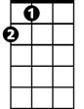

A

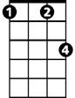

Fm



Bb

**Dm G7**

Just I and my friend.

**Dm G7 C**

We'll travel for miles in our Saturday smiles.

**F Em7**

And then we'll move on.

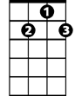

G7

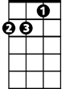

Dm

**F C Am Dm G7 C F C**

But we will remember, long after Saturday's gone.

**C F G7 (x3)**

Come Saturday morning

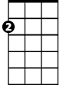

Am

Em7

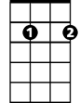

**C F Fm**

Come Saturday morning,

**C Bb**

I'm goin' away with my friend.

**F Bb Asus4 A Asus4 A**

We'll Saturday laugh more than half of the day.

**BARITONE**

**Dm G7**

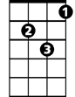

Dm



Am

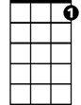

G7

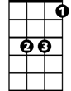

Bb

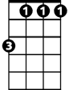

Fm



F

C



Just I and my friend.

**Dm G7 C**

Dressed up in our rings and our Saturday things.

**F Em7**

And then we'll move on.

**F C Am Dm G7 C**

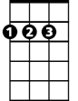

A

But we will remember, long after Saturday's gone.

**C F G7 (x3)**

Come Saturday morning

**(REPEAT FIRST VERSE)**

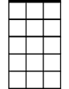

Em7

**C F G7 (x2)**

Come Saturday morning

**C F G7 C)**

Come Saturday morning