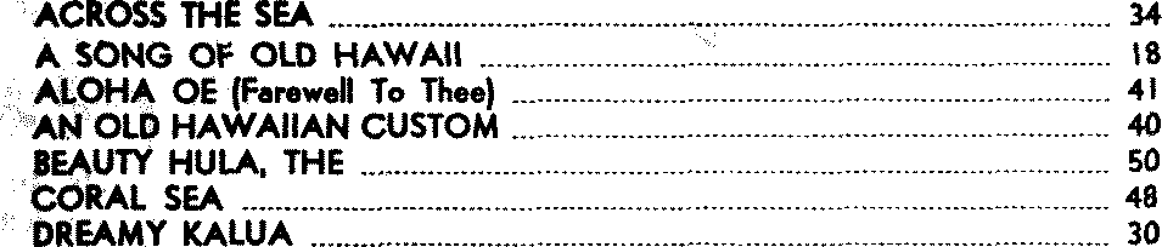

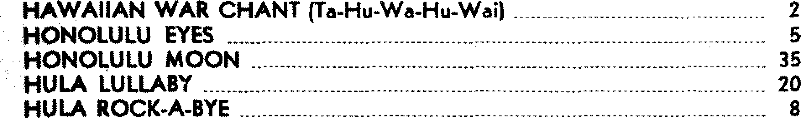DROWSY WATERS (Waflane) 24

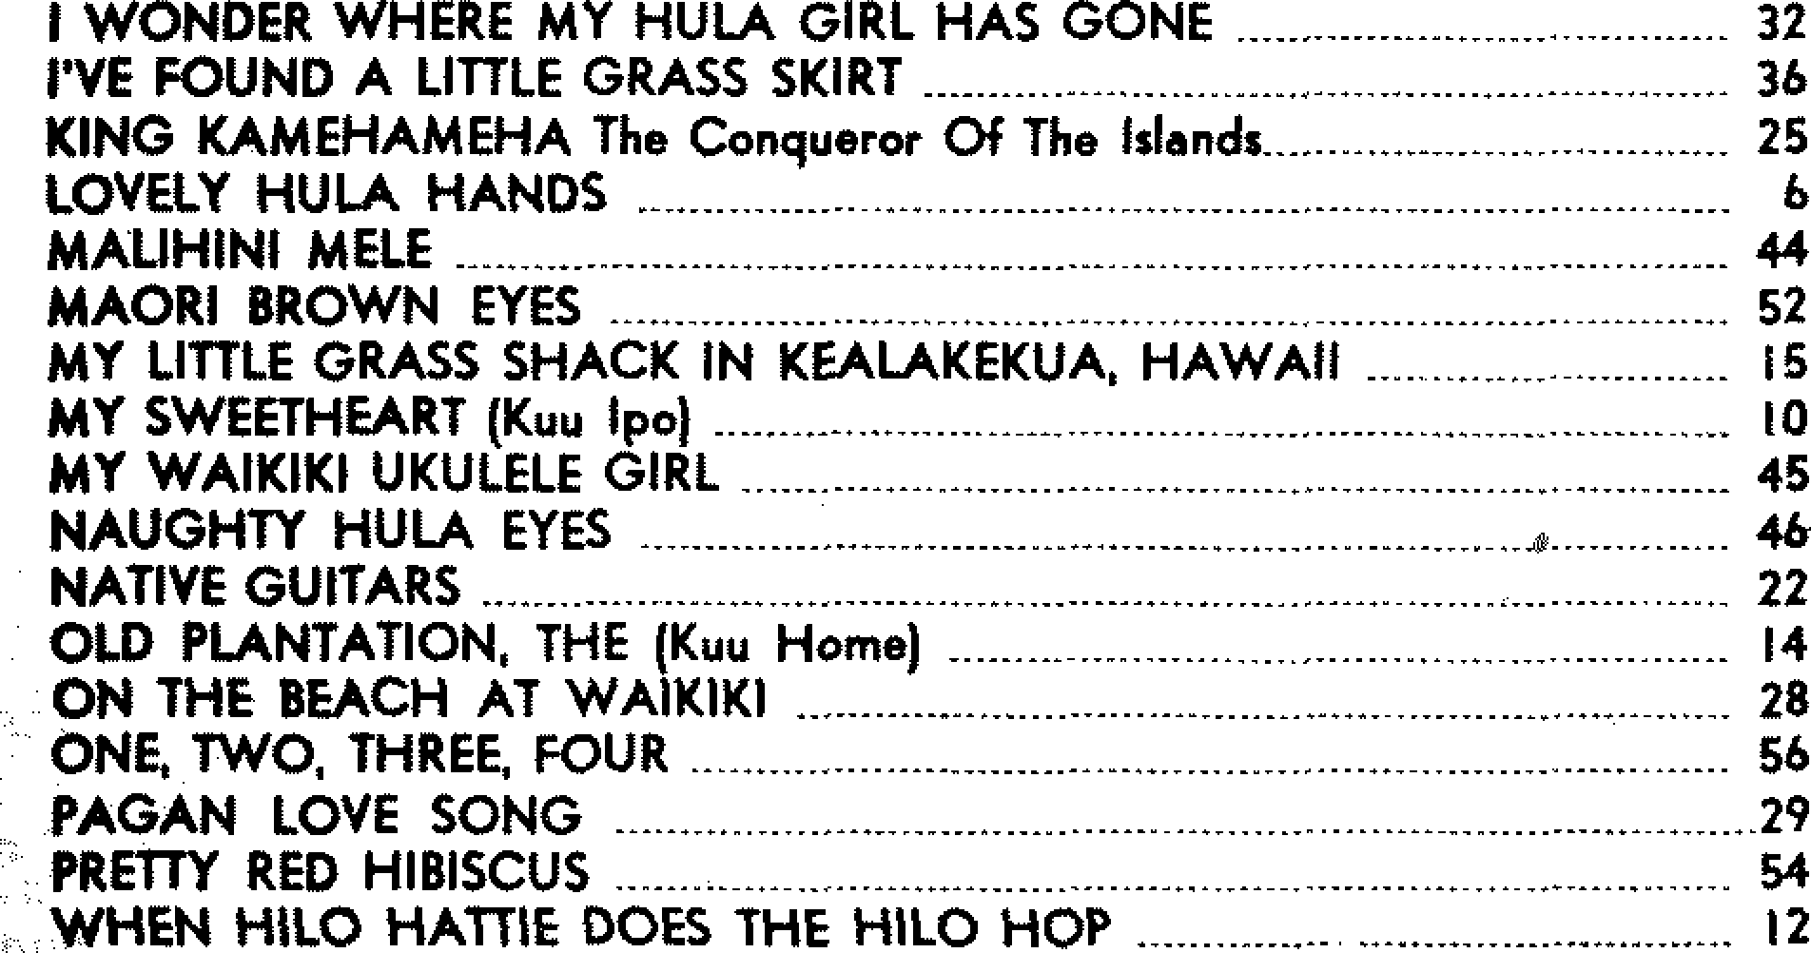I WAHT TO LEARH TO SPEAK HAWAIIAH 42