Corny Christmas Carol (Christmas Fun) (C)
Tim and Theresa Miller with Timothy Miller Hughes, Dec. 2016

Intro: C Am G C ( G7↓ )  C Am G C  Went down to the store today, we went to buy some corn,  C Am G C  Wanted to make corn cakes to eat on Christmas morn.  C Am G C  Going to have some company and many mouths to feed,  C Am G C  Good friends and nice cousins and food is what we need.  Chorus:  C Am G↓↓ C↓  We like making Christmas fun.  C Am G↓↓ C↓  Lots of fun for every one. (2x)  C Am G C  Went down to the store today, we went to buy some rice,  C Am G C  Thought we’d make rice pudding ‘cause it is extra nice.  C Am G C  Make it sweet and creamy with honey and some spice,  C Am G C  Adding nuts and raisins might make it twice as nice. Chorus  C Am G C  Went down to the store today, some apples for to buy,  C Am G C  Everything so jolly, delicious apple pie.  C Am G C  A’ la mode with ice cream, and other toppings, too,  C Am G C  All things so delicious for me and for you. Chorus  Outro G↓ C↓ |  |  |  |  |  |  |  | 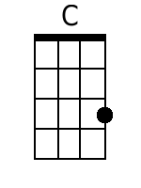
 |  |  |  |  |  |  |  | 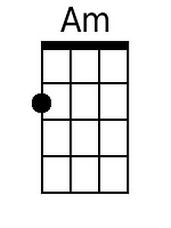
 |  |  |  |  |  |  |  | 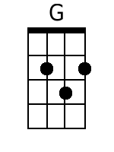
 |  |  |  |  |  |  |  | 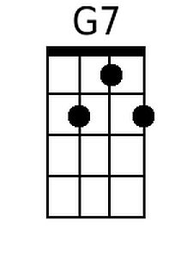
Baritone
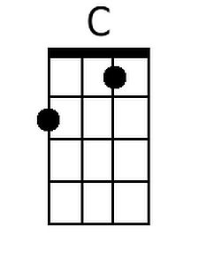 | 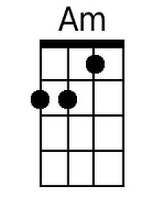 | 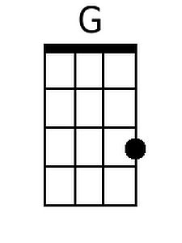 | 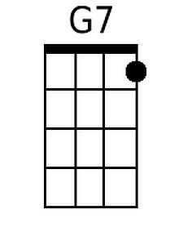

Corny Christmas Carol (Christmas Fun) (G)
Tim and Theresa Miller with Timothy Miller Hughes, Dec. 2016

Intro: G Em D G ( D7↓ )

G Em D G
Went down to the store today, we went to buy some corn,
G Em D G
Wanted to make corn cakes to eat on Christmas morn.
G Em D G
Going to have some company and many mouths to feed,
G Em D G
Good friends and nice cousins and food is what we need.

Chorus:
G Em D↓↓ G↓
We like making Christmas fun.
G Em D↓↓ F↓
Lots of fun for every one. (2x)

G Em D G
Went down to the store today, we went to buy some rice,
G Em D G
Thought we'd make rice pudding 'cause it is extra nice.
G Em D G
Make it sweet and creamy with honey and some spice,
G Em D G
Adding nuts and raisins might make it twice as nice. Chorus

G Em D G
Went down to the store today, some apples for to buy,
G Em D G
Everything so jolly, delicious apple pie.
G Em D G
A' la mode with ice cream, and other toppings, too,
G Em D G
All things so delicious for me and for you. Chorus

Outro D↓ G↓

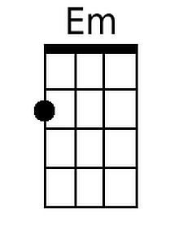
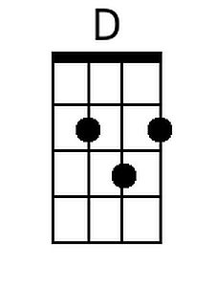
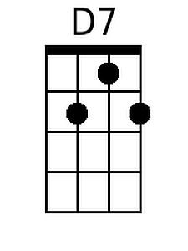
Baritone

