Cotton Fields
Written and recorded by Huddie William Ledbetter (aka Lead Belly), 1940s
Key of C
As performed by The New Christy Minstrels
Released on their album Chim Chim Cher-ee, 1965

Note:
Written and first recorded by Huddie William Ledbetter (aka Lead Belly) in the 1940s. It has been recorded by more than two dozen individuals and groups since then, in various tempos and with numerous adaptations of the lyrics.

YouTube Links

The New Christy Minstrels:
https://www.youtube.com/watch?v=eAq4quw6jwo

The Seekers:
https://www.youtube.com/watch?v=Lq7nwBqWaKY

The Highwaymen
https://www.youtube.com/watch?v=nXKBXh8OGs8

Creedance Clearwater Revival:
https://www.youtube.com/watch?v=o7wlmByH70g

Lead Belly (Huddie William Ledbetter):
https://www.youtube.com/watch?v=46h56pidCiE

Cotton Fields
Key of C
Written and recorded by Huddie William Ledbetter (aka Lead Belly), 1940s
As performed by The New Christy Minstrels, released on their album Chim Chim Cheree, 1965

GCEA  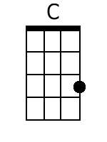  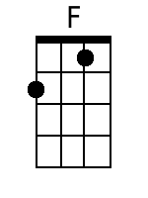  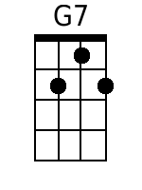  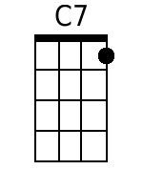  Bari  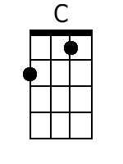  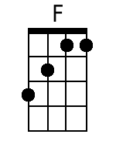  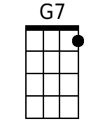  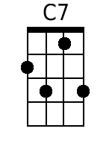 | C  1. When I was a little bitty baby  F C  My mama would rock me in that cradle  G7  In them old cotton fields back home.  C  When I was a little bitty baby  F C  My mama would rock me in that cradle  G7 C  In them old cotton fields back home.  Chorus  F  And when them cotton balls get rotten,  C  You can’t pick very much cotton  G7  In them old cotton fields back home  C C7  It was down in Louis-iana  F C  Just about a mile from Texar-kana  G7 C  In them old cotton fields back home.  C  2. I was over in Arkansas  F C  When the people ask me what you come here for  G7  In the old cotton fields back home  C  I was over in Arkansas  F C  When the people ask me what you come here for  G7 C  In the old cotton fields back home. Chorus  C  3. It must sound a little bit funny  F C  But you don't make very much money  G7  In them old cotton fields back home  C  It must sound a little bit funny  F C  But you don't make very much money  G7 C  In them old cotton fields back home.  Chorus  F  And when them cotton balls get rotten,  C  You can’t pick very much cotton  G7  In them old cotton fields back home  C C7  It was down in Louis-iana  F C  Just about a mile from Texar-kana  G7 C  In them old cotton fields back home.  C  4. When I was a little bitty baby  F C  My mama would rock me in that cradle  G7  In them old cotton fields back home  C  Yes, When I was a little bitty baby  F C  My mama would rock me in that cradle  G7 C  In them old cotton fields back home.

